

Fundamental in Programming

Best Auto Mart



MN Rizni Mohamed

JF/HDCSE/CMU/09/21

ST/20195902

**Assignment Cover Sheet**

|  |  |  |  |
| --- | --- | --- | --- |
| **Qualification** | | **Module Number and Title** | |
| HD in Computing and Software Engineering | | CSE 4002  Fundamentals in Programming | |
| **Student Name & No.** | | **Assessor** | |
| Mr.MN Rizni Mohamed (JF/HDCSE/CMU/09/21)  (St/20195902) | | Mr Danny Hamshananth | |
| **Hand over date** | | | **Submission Date** |
| 2021-02-10 | | | 2021-04-30 |
| **Assessment type** | **Duration/Length of**  **Assessment Type** | | **Weighting of Assessment** |
| **Coursework** | Report and Software Submission  (3000 words) | | 100% |

|  |  |
| --- | --- |
| **Learner declaration** | |
| I Mr.MN Rizni Mohamed (JF/HDCSE/CMU/09/21) (St/20195902), certify that the work submitted for this assignment is my own and research sources are fully acknowledged. | |
| |  |  |  |  | | --- | --- | --- | --- | | **Marks Awarded** | | | | | First assessor | |  | | | IV marks | |  | | | Agreed grade | |  | | | Signature of the assessor |  | Date |  | |

**Feedback Form**

**International College of Business & Technology**

**Module :** CSE 4002

**Student :**  Mr.MN Rizni Mohamed (JF/HDCSE/CMU/09/21) (St/20195902)

**Assessor :** Mr Danny Hamshananth

**Assignment :** FIP

**Strong features of your work:**

**Areas for improvement:**

**Marks Awarded:**

**Acknowledgment**

Praise and thank to the Almighty for the blessings and guidance to make myself possible to complete my report that can finally be accomplished as it should be. I would like to extent my special thanks to everyone who gave the opportunity to finish this report. The assistance provided by assessment supervisor Mr Danny Hamshananth was appreciable. Encouragement and suggestions, helped me to do the assessment and writing this report. Invested his full effort in guiding me to accomplishing the goal. I am highly indebted to ICBT for their guidance and constant supervision as well as for providing necessary information regarding the report & also for their support in completing the report in campus premises.

**List of contents**

Contents

Programming Methodologies 1

1. Procedural programming 1

2. Object-oriented Programming 2

3. Functional Programming 2

4. Logical programming 3

Control Structures 4

1. Sequential Control Structures 4

2. Selection Control Structures 4

• IF Statement 5

• IF-Else Statement 6

• Nested IF-Else Statement 6

• IF-Else Ladder/Else-IF Clause 7

• Switch Statements or Control Statements 8

3. Repetition / Loop Control Structure 8

1. indeterminate loops 8

2. determinate loops 10

Modularization 11

Introduction 12

Introduction 12

Structure of dissertation 12

Software Requirement Specification 13

Introduction 13

Motivation of the project 13

Objectives of the system 14

Scope of the propose system 14

Overall Description 14

User Needs 15

External Interface Requirements 15

Functional Requirements 15

Hardware Requirements 15

Software Requirements 16

Nonfunctional Requirements 16

Design of solution 17

Introduction 17

Process flow diagrams and maps 17

Flow chart 17

User Interface Design for the System 62

• Main menu 62

• Login 63

• Login success 63

• Manage login (user) 64

• Manage login (admin) 65

• Sign up 67

• Manage services & products 67

• Available Services (guest) 71

• Available Services (user and admin) 71

• Available Products (guest) 74

• Available Products (user and admin) 74

• Cart (user and admin) 77

Development 78

Introduction 78

Development environment 78

System Development Tools and Technologies 78

DEV C++ 78

VS Code 78

TDM-GCC Compiler 78

C++ V.11 79

Hierarchical Function Structure 79

Code Structure 80

Main requirements 80

Other requirements 88

Validation 118

Evaluation 121

Test plan – IEEE 829 121

Test Plan Identifier 121

References 121

Introduction 121

Test Items 121

Software Risk Issues 122

Features to be tested 122

Features not to be Tested 122

Approach 122

Item Pass/Fail Criteria 123

Suspension Criteria and Resumption Requirements 123

Test Deliverables 123

Remaining Test Tasks 123

Environmental Needs 124

Staffing and Training Needs 124

Responsibilities 124

Schedule 124

Planning Risks and Contingencies 124

Approvals 124

Test case 125

1. Login 125

2. Logout 128

3. Menu 129

4. Signup 131

5. Program exit 133

6. List service 133

7. Search service 134

8. Buy service 135

9. List product 136

10. Search product 137

11. Buy product 138

12. Add service 139

13. Delete service 140

14. Update service 141

15. Add product 142

16. Delete product 142

17. Update product 143

18. Change password 144

19. Delete account 145

20. List user accounts 146

21. Cart 147

Test summery report 150

User Accepting Testing (UAT) 151

Sample questionnaire 152

User feedback 157

Test conclusion 162

Future Recommendation 162

References 163

Appendix 165

questionnaire 165

**List of figures**

Figure 1 Procedural programming 1

Figure 2 object orientated programming 2

Figure 3 Functional Programming 3

Figure 4 Sequential control structure 4

Figure 5 1. Selection Control Structures 5

Figure 6 IF statement 6

Figure 7 IF-Else Statement 6

Figure 8 3. Nested IF-Else Statement 7

Figure 9 IF-Else Ladder/Else-IF Clause 7

Figure 10 Switch Statements or Control Statements 8

Figure 11 WHILE loop 9

Figure 12 DO-WHILE loop 10

Figure 13 FOR loop 10

Figure 14 Modularization 11

Figure 15 Flow chart Program starts 18

Figure 16 Flow chart main 18

Figure 17 Flow chart resetCartSystem 19

Figure 18 Flow chart menu 20

Figure 19 Flow chart Header 21

Figure 20 Flow chart guestmenu 22

Figure 21 Flow chart guestSelection 23

Figure 22 Flow chart usermenu 24

Figure 23 Flow chart userSelection 25

Figure 24 Flow chart adminmenu 26

Figure 25 Flow chart adminSelection 27

Figure 26 Flow chart Manage_user_accounts 28

Figure 27 Flow chart display_user_accounts 29

Figure 28 Flow chart deleteUserML 30

Figure 29 Flow chart availableService 31

Figure 30 Flow chart Available_Service_menu 32

Figure 31 Flow chart Available_Service_Selection 33

Figure 32 Flow chart availableProduct 34

Figure 33 Flow chart Available_Product_menu 35

Figure 34 Flow chart Available_Product_Selection 36

Figure 35 Flow chart List_Items 37

Figure 36 Flow chart buy_Item 38

Figure 37 Flow chart 39

Figure 38 Flow chart login 40

Figure 39 Flow chart signup 41

Figure 40 Flow chart logout 42

Figure 41 Flow chart admin_login_menu 42

Figure 42 Flow chart Manage_login 43

Figure 43 Flow chart admin_login_Selection 44

Figure 44 Flow chart user_login_menu 45

Figure 45 Flow chart Manage_Services_Proucts_menu 45

Figure 46 Flow chart user_login_Selection 46

Figure 47 Flow chart changePassword 47

Figure 48 Flow chart deleteAccount 48

Figure 49 Flow chart Manage_Services_Proucts 49

Figure 50 Flow chart Manage_Services_Proucts_Selection 50

Figure 51 Flow chart Add_Services 51

Figure 52 Flow chart Delete_Services 52

Figure 53 Flow chart Update_Services 53

Figure 54 Flow chart Add_Products 54

Figure 55 Flow chart Delete_Products 55

Figure 56 Flow chart Update_Products 56

Figure 57 Flow chart cart 57

Figure 58 Flow chart find_price_delete_cart 58

Figure 59 Flow chart bill 59

Figure 60 Flow chart money_total 60

Figure 61 Flow chart delete_S_P 61

Figure 62 main menu of guest 62

Figure 63 main menu of user 62

Figure 64 main menu of admin 63

Figure 65 login success 63

Figure 66 login fail 64

Figure 67 manage login of user 64

Figure 68 manage login of admin 65

Figure 69 change password 65

Figure 70 manage user accounts of admin 66

Figure 71 delete account 66

Figure 72 sign up 67

Figure 73 manage services & products 67

Figure 74 add services 68

Figure 75 delete services 68

Figure 76 update services 69

Figure 77 add products 69

Figure 78 delete products 70

Figure 79 update products 70

Figure 80 available services of guest 71

Figure 81 available services of user and admin 71

Figure 82 list services 72

Figure 83 search services 73

Figure 84 buy service of user and admin 73

Figure 85 available products of guest 74

Figure 86 available Products of user and admin 74

Figure 87 list products 75

Figure 88 search products 76

Figure 89 buy product of user and admin 76

Figure 90 cart of user and admin 77

Figure 91 Basic hierarchical Function Structure 79

Figure 92 add products 80

Figure 93 delete products 81

Figure 94 update products 82

Figure 95 add services 83

Figure 96 delete services 84

Figure 97 update services 85

Figure 98 list available services and products 86

Figure 99 search specific product or service 87

Figure 100 user login 88

Figure 101 logout 89

Figure 102 exit 89

Figure 103 headers 90

Figure 104 function prototyping 92

Figure 105 global Variable 92

Figure 106 main 92

Figure 107 reset cart system 93

Figure 108 header 93

Figure 109 money total 94

Figure 110 menu 95

Figure 111 guest menu 96

Figure 112 guest selection 96

Figure 113 available service 97

Figure 114 available service menu 97

Figure 115 available service selection 98

Figure 116 buy item 100

Figure 117 available product 100

Figure 118 available product menu 101

Figure 119 available product selection 101

Figure 120 admin menu 102

Figure 121 admin selection 102

Figure 122 manage services products 103

Figure 123 manage services products menu 104

Figure 124 manage services products selection 104

Figure 125 core function of delete service and product 105

Figure 126 user menu 106

Figure 127 user selection 106

Figure 128 sign up 107

Figure 129 manage login 108

Figure 130 admin login menu 108

Figure 131 admin login selection 109

Figure 132 user login menu 110

Figure 133 user login selection 110

Figure 134 change password 111

Figure 135 delete account 112

Figure 136 delete user in master login 113

Figure 137 manage user accounts 114

Figure 138 display user accounts 115

Figure 139 cart 116

Figure 140 bill 117

Figure 141 find the price of item in the cart to delete 117

Figure 142 UAT sample questionnaire page 1 152

Figure 143 UAT sample questionnaire page 2 153

Figure 144 UAT sample questionnaire page 3 154

Figure 145 UAT sample questionnaire page 4 155

Figure 146 UAT sample questionnaire page 5 156

Figure 147 UAT user feedback page 1 157

Figure 148 UAT user feedback page 2 158

Figure 149 UAT user feedback page 3 159

Figure 150 UAT user feedback page 4 160

Figure 151 UAT user feedback page 5 161

**List of tables**

Table 1 Implantation environment 78

Table 2 Remaining test task 124

Table 3 Test case Login 125

Table 4 Test case login - admin results 126

Table 5 Test case login - user results 127

Table 6 Test case logout 128

Table 7 Test case logout - admin results 128

Table 8 Test case logout - user results 128

Table 9 Test case menu 129

Table 10 Test case menu - admin 129

Table 11 Test case menu - user 130

Table 12 Test case menu - guest 130

Table 13 Test case signup 131

Table 14 Test case signup - admin 132

Table 15 Test case signup - user 132

Table 16 Test case program exit 133

Table 17 Test case program exit result 133

Table 18 Test case list service 133

Table 19 Test case list view result 134

Table 20 Test case search service 134

Table 21 Test case search service results 135

Table 22 Test case buy service 135

Table 23 Test case buy service result 136

Table 24 Test case list product 136

Table 25 Test case list product result 137

Table 26 Test case search product 137

Table 27 Test case search product results 138

Table 28 Test case buy product 138

Table 29 Test case buy product result 139

Table 30 Test case add service 139

Table 31 Test case add service result 139

Table 32 Test case Delete service 140

Table 33 Test case Delete service results 140

Table 34 Test case Update service 141

Table 35 Test case Update service result 141

Table 36 Test case add product 142

Table 37 Test case add product 142

Table 38 Test case delete product 142

Table 39 Test case delete product 143

Table 40 Test case update product 143

Table 41 Test case update product results 144

Table 42 Test case change password 144

Table 43 Test case change password result 145

Table 44 Test case delete account 145

Table 45 Test case delete account results 145

Table 46 Test case list user accounts 146

Table 47 Test case list user accounts results 146

Table 48 Test case cart 147

Table 49 Test case cart results 149

Table 50 Test summery report 150

# Programming Methodologies

When systems are designed to resolve challenges in everyday life, they appear to be enormous and complicated. The approach to analysis, preparation and management of the production phase of such complex problems is the programming methodology. There are 3 types in programming methodologies. Those are:

1. Procedural Programming
2. Object-oriented Programming
3. Functional Programming
4. Logical Programming

(Programming Methodologies - Introduction - Tutorialspoint, 2021)

## Procedural programming

Procedural programming can be described as a programming model based on the principle of calling procedure derived from structured programming. Procedures, also referred to as routines, substrates or functions, are essentially a sequence of calculations to be performed. During the execution of a program, any other operation, or other processes or itself, may be called at any time.

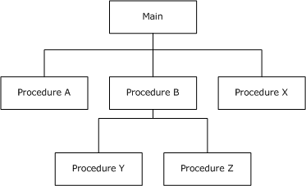

Figure 1 Procedural programming

Example: For developing calculator program, addition, subtraction, multiplication, divisions are will develop as separate procedures and call it into main module when user needs.

(Differences between Procedural and Object-Oriented Programming - GeeksforGeeks, 2021)

## Object-oriented Programming

Object-oriented programming (OOP) is a programming framework based on the class and the object principle. It is used to organize a software program in plain, reusable code sheets that serve to construct individual instances of objects (usually known as classes).

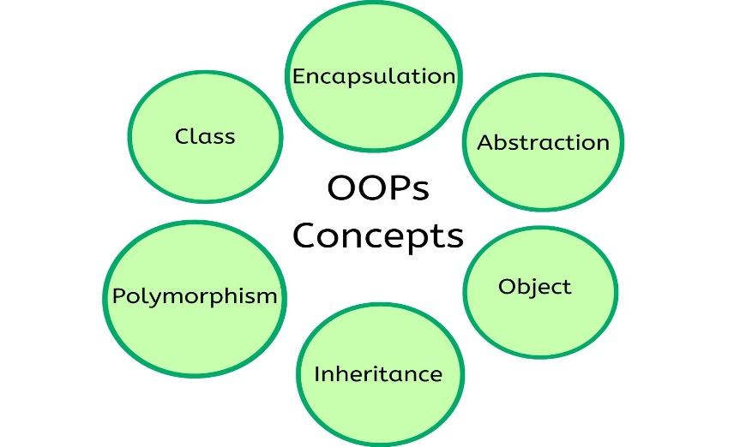

Figure 2 object orientated programming

Example: We built a car class to include all the features that a car needs, colour, brand, and model. Then we build an instance of an object class vehicle, myCar, to display my particular car. The value of the properties described in the class may be set to represent my vehicle, without affecting the class template or other objects. This class can be reused to display any number of vehicles.

(What is Object Oriented Programming? OOP Explained in Depth, 2021)

## Functional Programming

The method of software building, by pure functioning, avoids share status, mutable data and side-effects, is functional programming (often abbreviated FP). The declarative rather than the obligatory functional programming, and pure functionality is the device state. Contrast to object-oriented programming, which normally shares the application state and place it in an object using methods.

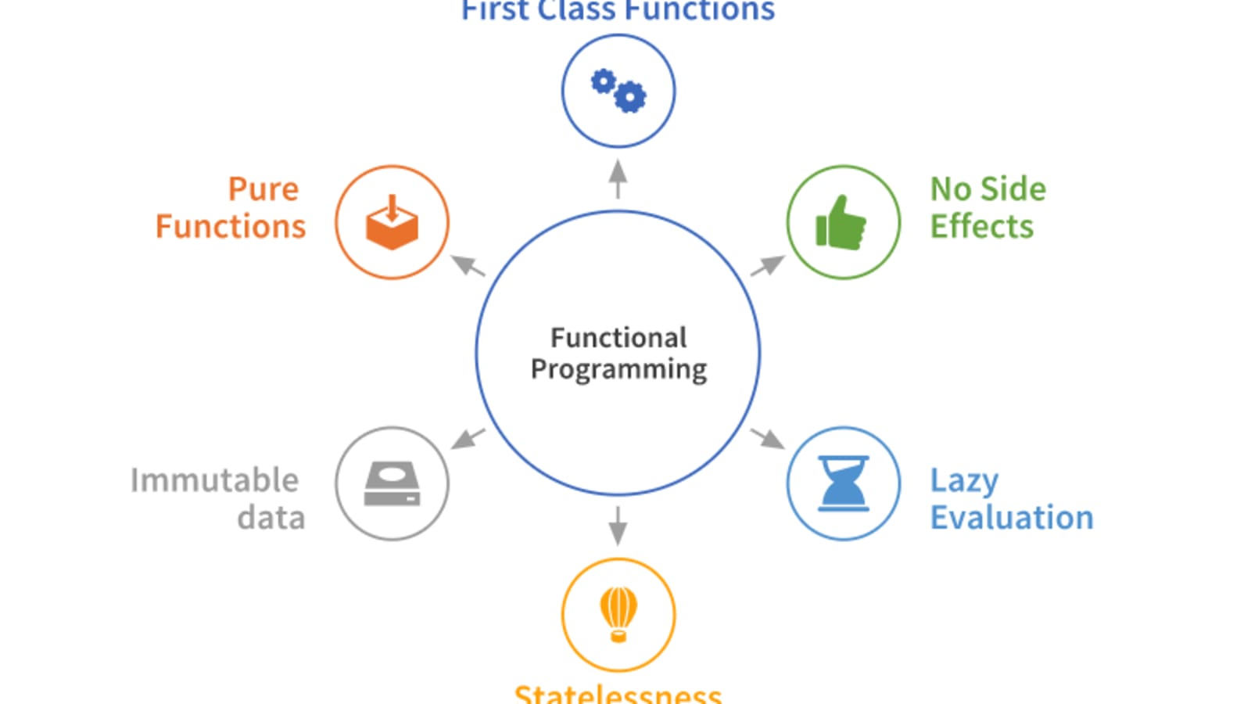

Figure 3 Functional Programming

Examples: Functional units such as employee data maintenance, simple payroll calculations, gross compensation estimate, leave processing and loan refund processing may provide a payroll processing.

(Master the JavaScript Interview: What is Functional Programming?, 2021)

## Logical programming

Logical programming is a theory of programming focused primarily on formal logic. Every program that is written in a language of logical programming is a logical collection of phrases representing facts and rules regarding a problem field.

Example: Users have very defined functions in a school management system including instructor, professor, laboratory assistant, supervisor, academic officer, etc. Thus, according to functions of consumer the software can be split in units. Each user can have various interfaces, permissions, etc.

(Logic programming - Wikipedia, 2021)

# Control Structures

Control structures take program flow decisions based on parameters defined. It must be defined prior to coding, which are very essential elements of any program. Analysts and programmers use algorithms and pseudocodes to define the control structures that are required.

There are the three kinds of control systems.

1. Sequential Structures
2. Selection Structures
3. Repetition / Loop Control Structures

(Control Structures, 2021)

## Sequential Control Structures

"Sequence control structure" means the line-by-line execution of statements in the same order in which they are executed in the program. For example, they may perform a number of read or write operations, arithmetic procedures or variable assignments.

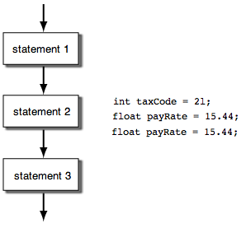 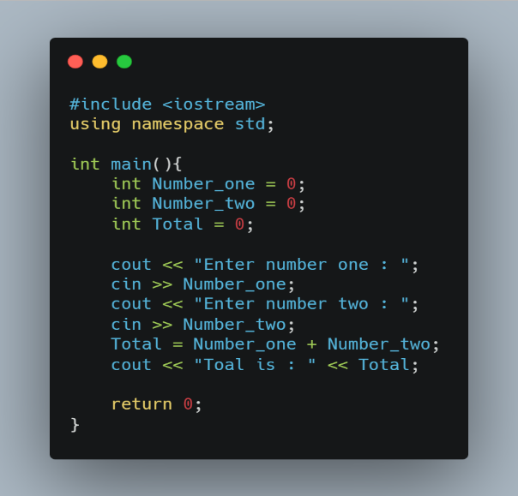

Figure 4 Sequential control structure

(What is the Sequence Control Structure?, 2021)

## Selection Control Structures

In order to control sequences, statements in the same order in which they appear in the program are performed sequentially. Although you hardly want to execute the declarations successively in serious programming. You also want to execute a block of statements in one situation and a completely opposite block of statements in another situation. A decision-making structure should take steps in this respect!

The decision Control structure considers a Boolean term or a series of Boolean phrases and then determines which block of statements to implement.

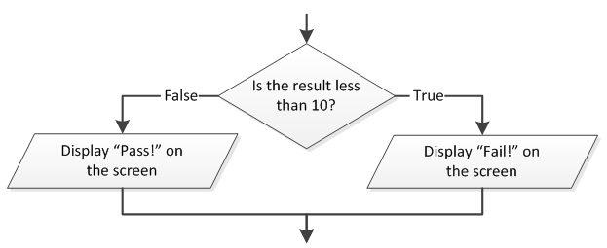

Figure 5 1. Selection Control Structures

(What is a Decision Control Structure?, 2021)

There are 5 kinds in Selection Control Structure

1. IF Statement
2. IF-Else Statement
3. Nested IF-Else Statement
4. IF-Else Ladder/Else-IF Clause
5. Switch Statements or Control Statements

(The Decision Control Structure - C Programming, 2021)

### IF Statement

IF Statement checks a given condition and if returns a TRUE value then code block of true will executed

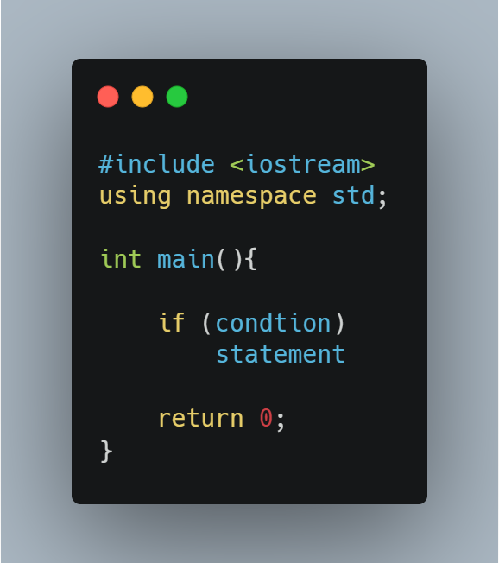 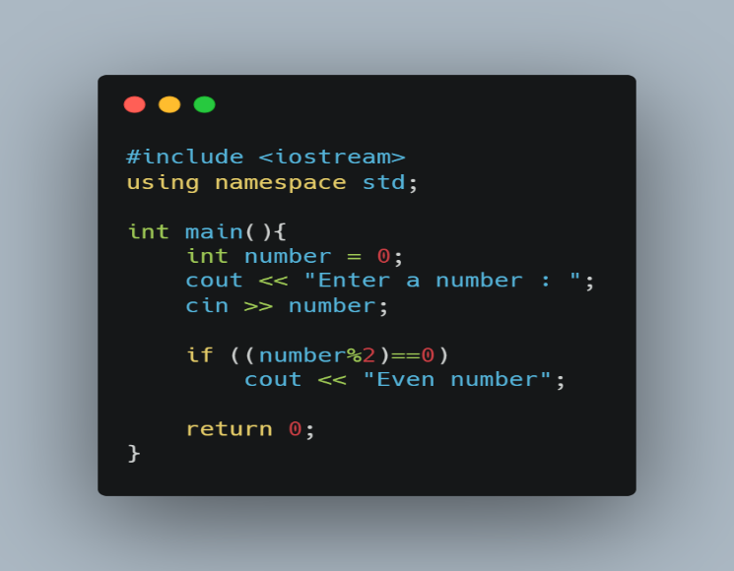

Figure 6 IF statement

### IF-Else Statement

IF-Else Statement checks a given condition and if returns a TRUE value then code block of true will executed else code block of false will executed

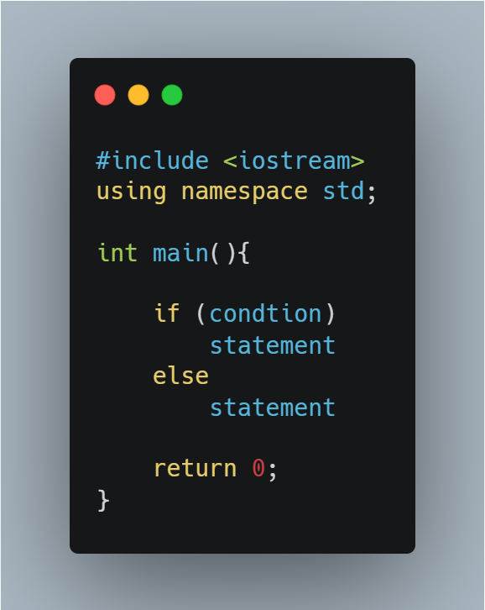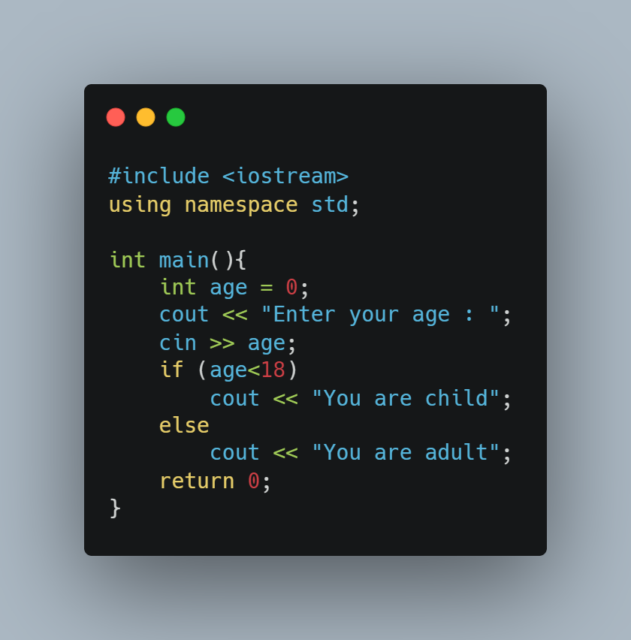

Figure 7 IF-Else Statement

### Nested IF-Else Statement

When a IF-Else statement contain one or more IF-Else statement/s inside in it then that’s known as Nested IF-Else

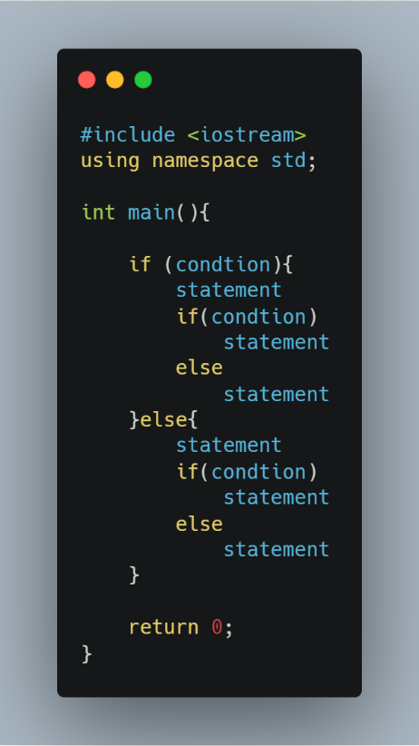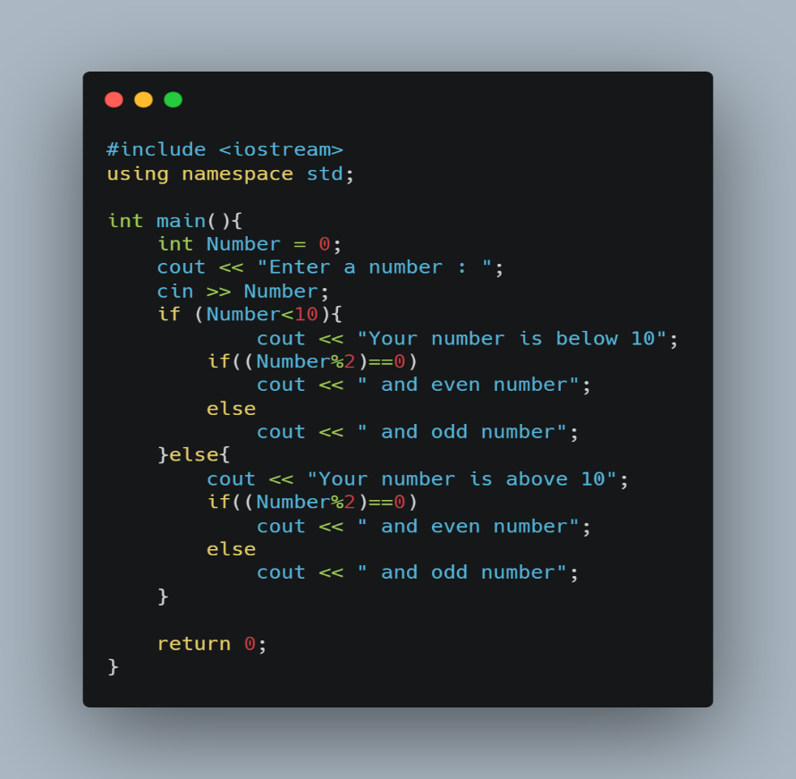

Figure 8 3. Nested IF-Else Statement

### IF-Else Ladder/Else-IF Clause

IF-Else Ladder/Else-IF Clause is the other approach is the most common way to make a multi-way decision.

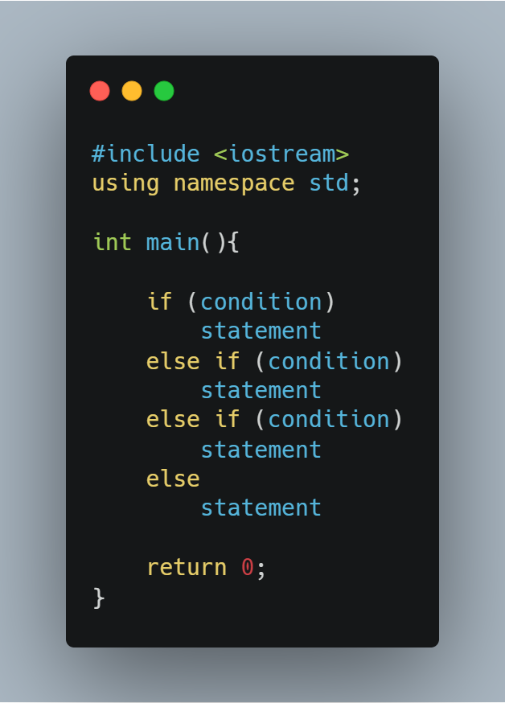 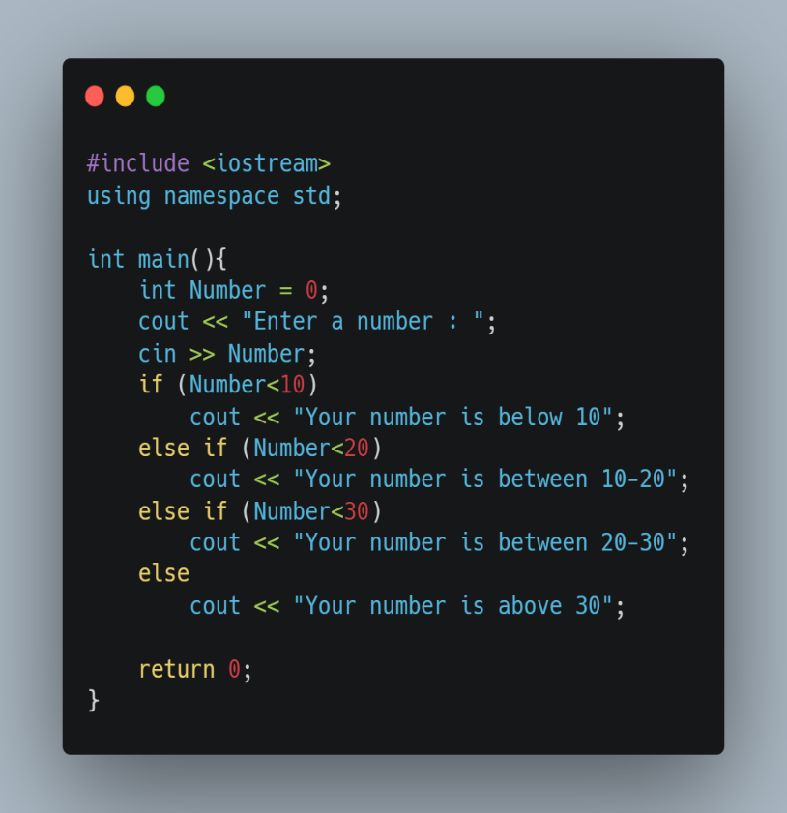

Figure 9 IF-Else Ladder/Else-IF Clause

### Switch Statements or Control Statements

The switch statement is a multi-way judgment that checks whether an expression fits one of a certain number of constant integer values.

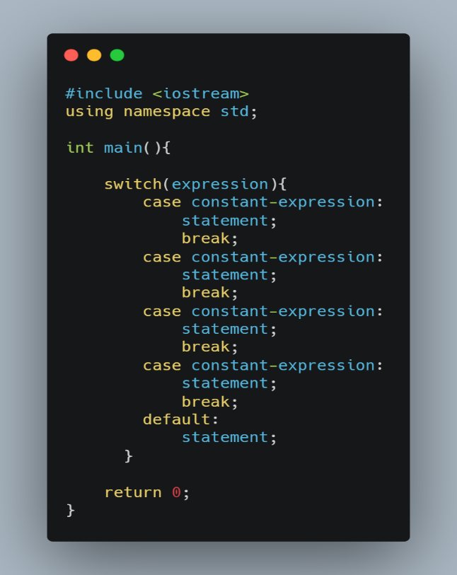 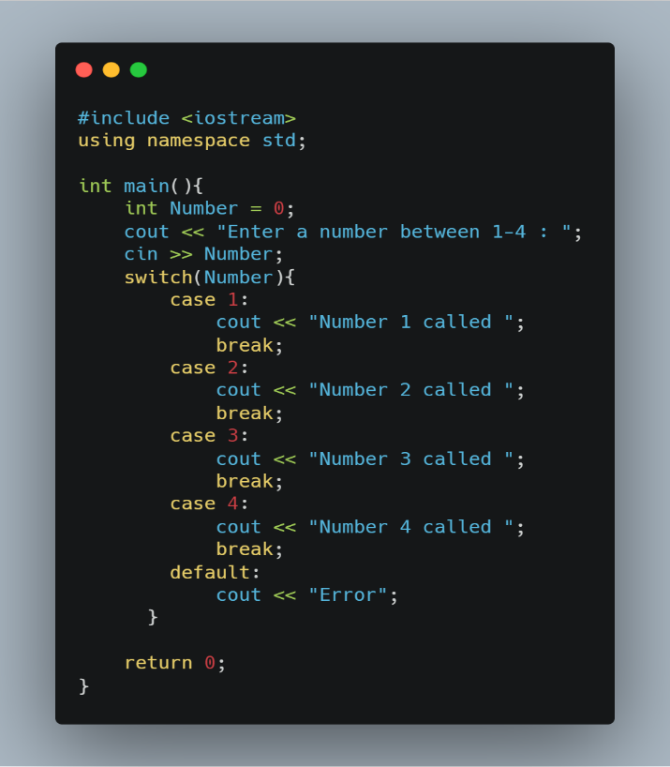

Figure 10 Switch Statements or Control Statements

## Repetition / Loop Control Structure

Repetitive control systems are groupings of codes, also known as iterative structures, structured to repeated a number of connected statements. This repeat may be repeated zero or more times before any control value or condition stops the repetition. Generally, there are two loops:

1. indeterminate loops
2. determinate loops

(Intro to Repetition Structures, 2021)

### indeterminate loops

A loop structure is indeterminate as long as a condition assesses a certain boolean value. Unlike the programmer knows precisely how many time iterations are needed, indeterminate loops can be used.

here are two types of indeterminate loops:

1. pre-test loops
2. post-test loops

(Intro to Repetition Structures, 2021)

#### Pre-test loops

In pre-test loops, the loop body will execute after the loop condition is checked. Thus, for the probability for the body execution can be zero. Best example for this is WHILE loop

##### WHILE loop

The while loop is running through a code block, as long as a certain condition is valid.

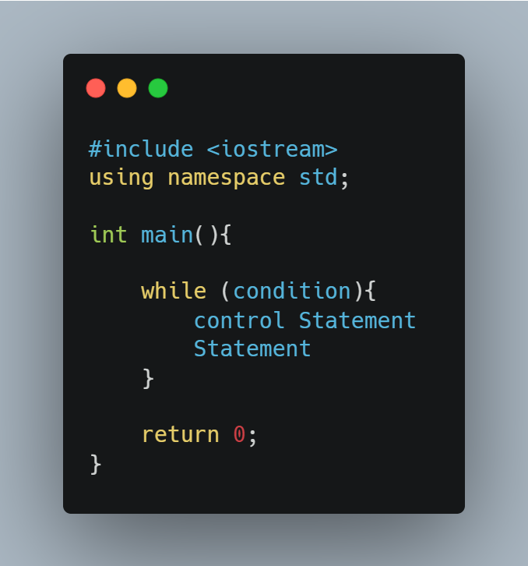 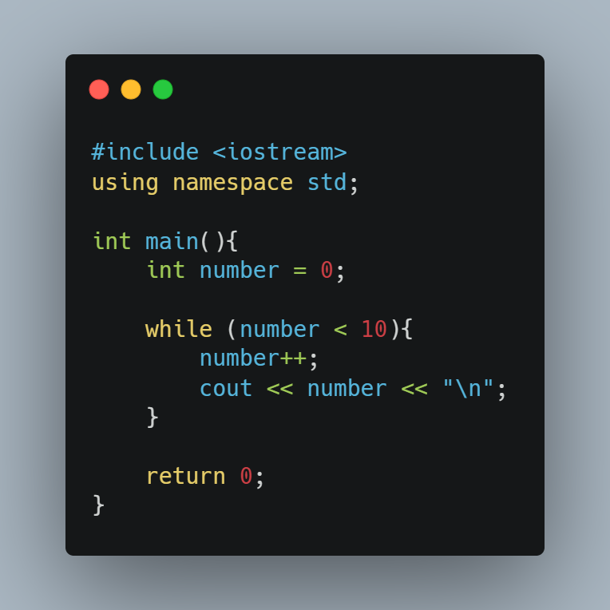

Figure 11 WHILE loop

(JavaScript while Loop, 2021)

#### post-test loops

In post-test loops, the loop body execute first and then loop condition will be checked. Thus, the probability of loop body execution is minimum one. Best example for this is DO-WHILE loop

##### DO-WHILE loop

The loop is identical to the while loop with a significant exception. At least once is the body of the do-while loop performed.

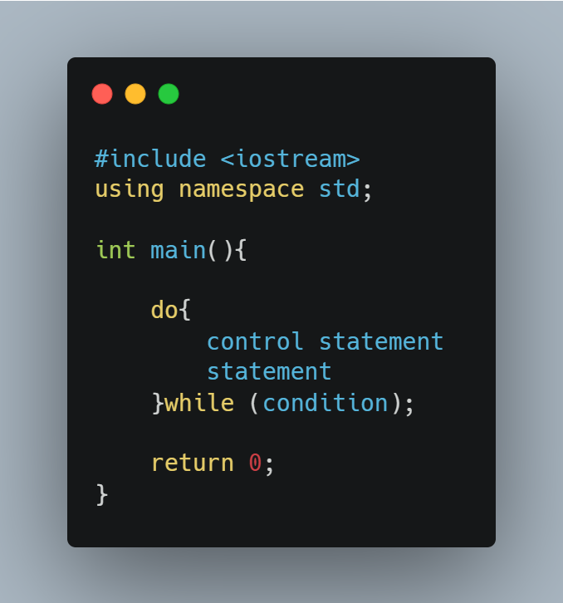 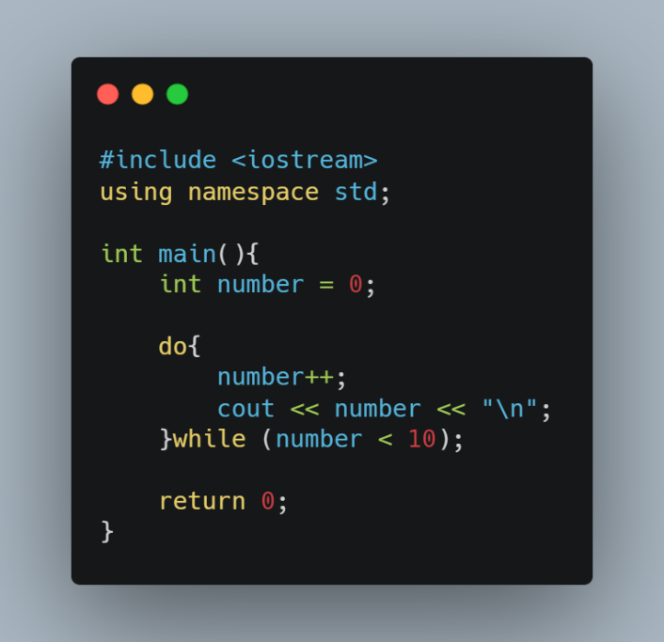

Figure 12 DO-WHILE loop

### determinate loops

In determinate loops can be predict that how many times its going to loop through it. Best example for determinate loop is FOR loop

#### FOR loop

There are two part of a for-loop: one header with the iteration and one body per iteration that is executed once. The header always declares an explicit loop variable, which enables the body to know which is performed. it generally used when before joining the loop the number of iterations is specified.

(For loop - Wikipedia, 2021)

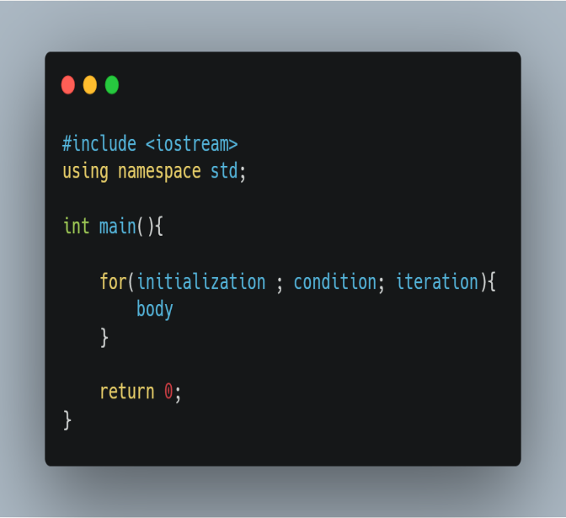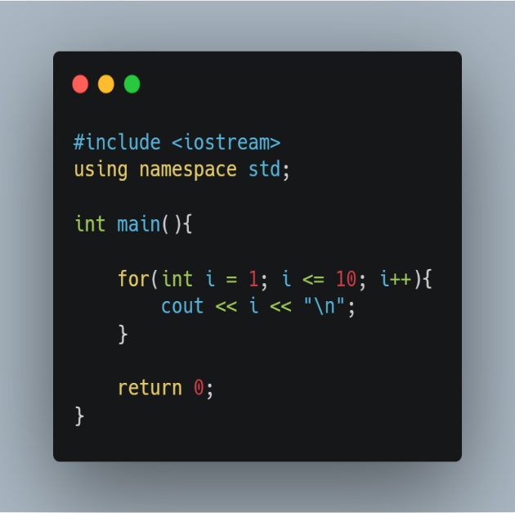

Figure 13 FOR loop

# Modularization

Modular programming is a software design process which emphasizes the division of the functionality of a program into interchangeable independent modules in such a way that each contains everything necessary to perform just one aspect.

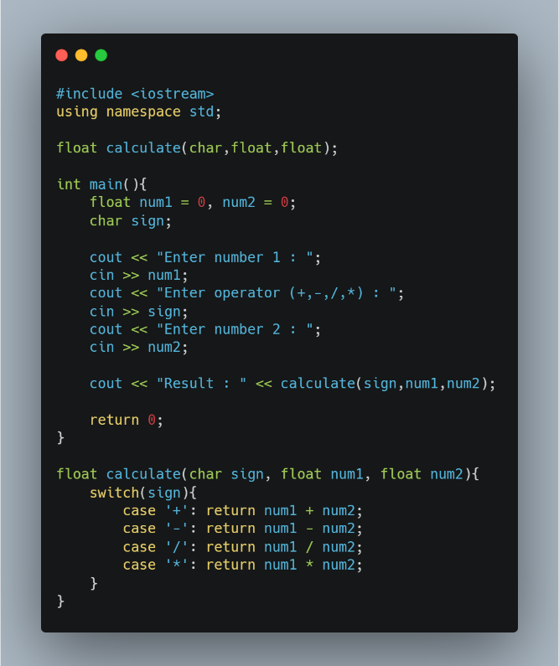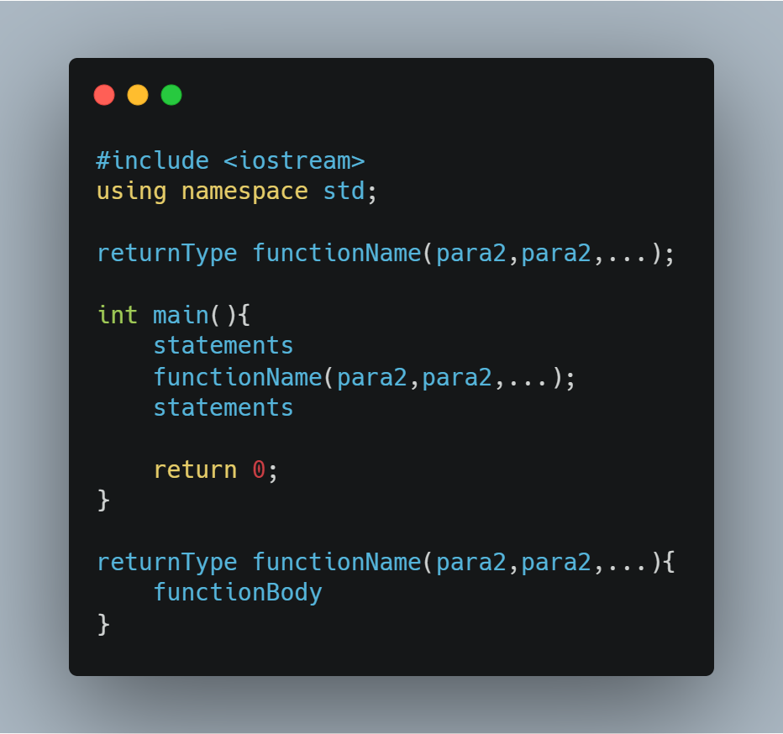

Figure 14 Modularization

(Modular programming - Wikipedia, 2021)

# Introduction

## Introduction

In our current mostly every human is being related with vehicles, that can be a manufacturing, distributing, using and repairing. In Sri Lanka, Best Auto Mart is a company which located in the Colombo city. in nowadays it’s using manual system for manage all works such as accounting process, managing process, customer ordering process and so on. Since it be a manual system, it facing lots of struggles such as billing process when customer traffic is high, manual counting for inventory items is not accurate, difficulties in listing available service and products to the customer and so on. So now Best Auto Mart company is decided to computerized all the company works

## Structure of dissertation

This report is detailly describing about all the process that made for computerized best auto mart company works under five topics. Those are software requirement specification, design of solution, development, evaluation and conclusion

Software requirement specification

In this section, it has 3 subroutines, firstly introduction. In this part introduction of the Best Auto Mart Company, motivation of the project, objectives of the project and scope of the proposing system are detailly explained. Second part is overall description. In this part overall description of proposing system and user roles and their needs are detailly explained. Finally in third part external interface requirements are detailly explained under the category of functional requirements, hardware requirements, software requirements and non-functional requirements.

Design of solution

In this section firstly introduction of designing is given and after process flow diagrams and maps is explained. Then entire system’s flow chart is attached. Finally entire system’s user interface design is attached and explained.

Development

In this section firstly introduction of development is given and after development environment and system development tools and technologies used for this project is clearly mentioned. After that, hierarchical function and code structure are attached. Finally, validation process of system is clearly mentioned.

Evaluation

In this section test plan is explained clearly. After test cases are attached with screenshots of actual result. Ten test summery report is given. Finally, user accepting testing is clearly explained with UAT questionnaire.

Conclusion

In this section firstly introduction of conclusion of this project is explained. And after critical assessment of the project and future recommendations are clearly discussed.

# Software Requirement Specification

A software specifications specification (SRS) is a concise overview of the functional and non-functional requirements of a software system to be built. The SRS is focused on the customer-contractor arrangement. It could include use cases for how the user will interact with the software system.

(Jain, Jain, Testing and Soma, 2021)

## Introduction

### Motivation of the project

Recently the Best Auto Mart (BAT) commenced an analysis regarding to company efficiency status. In now days BAT receiving high customer traffic which leads to many difficulties

* Difficulties in view available products and services
* Difficulties in Billing process
* Difficulties in inventory management

Therefore, the need of computerized system for BAT company is evolved to reduce all difficulties.

### Objectives of the system

Main objectives of the computerized BAT system are:

* View all the available service and products within short time
* Create invoices automatically
* Search and find the services and products in short time

### Scope of the propose system

Scope of the computerized BAT system is, reducing workloads, work’s time complexity and able to manage all the customers easily.

## Overall Description

Computerized BAT system software is having 3 user roles and those are in different permission levels according to their work descriptions.

Fist user roles is guest, in this type of user can view available products and services and also can search services and products. Guest user can create a new account in the system via signup process and able to become second level user

Second user role is user (Customer), in this type of user can view available products and services and also can search services and products. Additionally, they can add services and products to the cart for buying process. Also, they can remove services and products from cart. This type user can change their account password and also able to delete their account permanently from the system.

Third user role is admin, in this type of user can view available products and services and also can search services and products. Admin user can add or remove or update the both services and products in the system. They can add services and products to the cart for buying process. Also, they can remove services and products from cart. This type user can change their account password and also able to delete their account permanently from the system. Finally, admins can view all user role’s username and password and able to delete the account or change the password of all accounts.

### User Needs

User is need to have a knowledge in modern technology devices and handling methods. Also, user need to have a fully knowledge in handling BAT computerized system software for their works.

## External Interface Requirements

This section shall describe the interface requirements for the Best Auto Mart system. They specify the way the user shall interact with the system as well as define the necessary hardware interfaces and communication interfaces required by the software to store and retrieve data.

### Functional Requirements

Main requirements

* Manage available services and products (add, delete, update)
* List available services and products.
* Search specific product or service.

Other requirements are

* User login.
* Logout.
* Exit

### Hardware Requirements

1. Computer
   1. 512MB RAM
   2. Dual core processor
   3. Monitor
   4. Keyboard
   5. 10gb HDD
2. Printer

### Software Requirements

1. Windows 7 or higher
2. Printer driver

### Nonfunctional Requirements

1. User friendly interface

BAT system’s interface has navigation bar which help users to understand the software flow. And also, it has total price of purchased items is show on right top corner

1. Security

all asking prompts are validated to prompt needs

# Design of solution

## Introduction

Systems design is the process to define systems elements for a system based on the defined specifications such as the modules, architecture, components and their interfaces and data. It is the process of identifying, creating and designing systems that meet a company or organization's particular needs and requirements.

## Process flow diagrams and maps

Process flow diagrams (PFD) are a graphical method for the description and sequence of a process. A PFD supports method design brainstorming and collaboration. A full list of tasks including the process under examination is required for the PFMEA process. The team will determine the level of detail. It takes time to provide more information, but it decreases the chance of failure modes being missing.

(Process Flow Diagram - an overview | ScienceDirect Topics, 2021)

### Flow chart

A flow chart is a sequence-linked image of the individual process phases. It is a common tool that can be used to define many processes for a wide range of purposes. It is one of the seven fundamental tools of process analysis.

(What is a Flowchart? Process Flow Diagrams & Maps | ASQ, 2021)

All flow chart is deigned in VISIO 2019 software. You can clearly view all the flow chart designs in below link.

<https://drive.google.com/file/d/1gA-W3pXHZG31t5hn2VI7QeE6JngTnvtK/view>

#### program starts



Figure 15 Flow chart Program starts

#### main



Figure 16 Flow chart main

#### resetCartSystem



Figure 17 Flow chart resetCartSystem

#### menu



Figure 18 Flow chart menu

#### Header



Figure 19 Flow chart Header

#### guestmenu



Figure 20 Flow chart guestmenu

#### guestSelection



Figure 21 Flow chart guestSelection

#### usermenu



Figure 22 Flow chart usermenu

#### userSelection



Figure 23 Flow chart userSelection

#### adminmenu



Figure 24 Flow chart adminmenu

#### adminSelection



Figure 25 Flow chart adminSelection

#### Manage_user_accounts



Figure 26 Flow chart Manage_user_accounts

#### display_user_accounts



Figure 27 Flow chart display_user_accounts

#### deleteUserML



Figure 28 Flow chart deleteUserML

#### availableService



Figure 29 Flow chart availableService

#### Available_Service_menu



Figure 30 Flow chart Available_Service_menu

#### Available_Service_Selection



Figure 31 Flow chart Available_Service_Selection

#### availableProduct



Figure 32 Flow chart availableProduct

#### Available_Product_menu



Figure 33 Flow chart Available_Product_menu

#### Available_Product_Selection



Figure 34 Flow chart Available_Product_Selection

#### List_Items



Figure 35 Flow chart List_Items

#### buy_Item



Figure 36 Flow chart buy_Item

#### Search_Items



Figure 37 Flow chart

#### login



Figure 38 Flow chart login

#### signup



Figure 39 Flow chart signup

#### logout



Figure 40 Flow chart logout

#### admin_login_menu



Figure 41 Flow chart admin_login_menu

#### Manage_login



Figure 42 Flow chart Manage_login

#### admin_login_Selection



Figure 43 Flow chart admin_login_Selection

#### user_login_menu



Figure 44 Flow chart user_login_menu

#### Manage_Services_Proucts_menu



Figure 45 Flow chart Manage_Services_Proucts_menu

#### user_login_Selection



Figure 46 Flow chart user_login_Selection

#### changePassword



Figure 47 Flow chart changePassword

#### deleteAccount



Figure 48 Flow chart deleteAccount

#### Manage_Services_Proucts



Figure 49 Flow chart Manage_Services_Proucts

#### Manage_Services_Proucts_Selection



Figure 50 Flow chart Manage_Services_Proucts_Selection

#### Add_Services



Figure 51 Flow chart Add_Services

#### Delete_Services



Figure 52 Flow chart Delete_Services

#### Update_Services



Figure 53 Flow chart Update_Services

#### Add_Products



Figure 54 Flow chart Add_Products

#### Delete_Products



Figure 55 Flow chart Delete_Products

#### Update_Products



Figure 56 Flow chart Update_Products

#### cart



Figure 57 Flow chart cart

#### find_price_delete_cart



Figure 58 Flow chart find_price_delete_cart

#### bill



Figure 59 Flow chart bill

#### money_total



Figure 60 Flow chart money_total

#### delete_S_P



Figure 61 Flow chart delete_S_P

## User Interface Design for the System

### Main menu

#### Guest

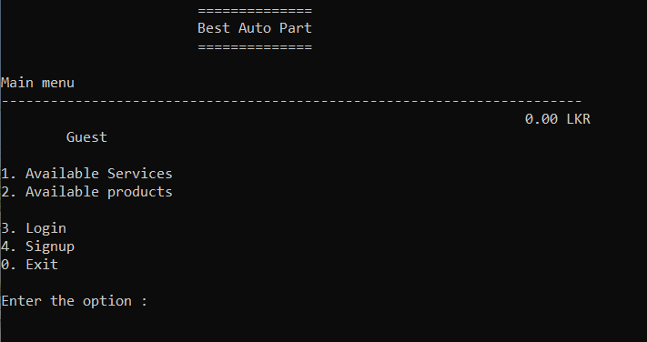

Figure 62 main menu of guest

#### User

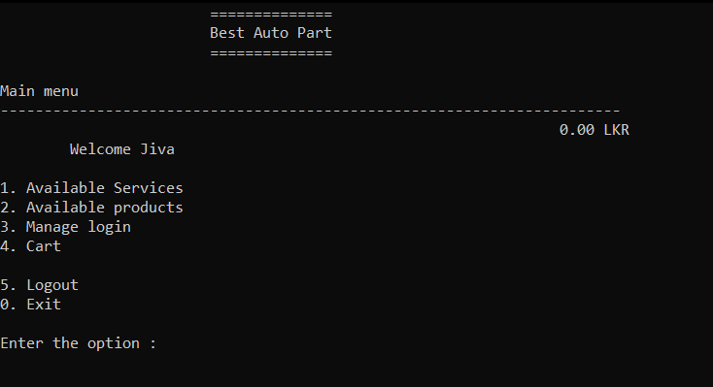

Figure 63 main menu of user

#### Admin

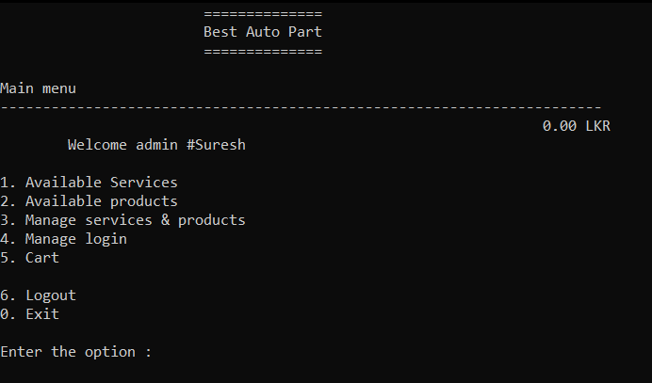

Figure 64 main menu of admin

### Login

#### Login success

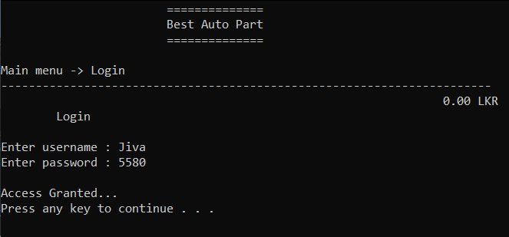

Figure 65 login success

#### **Login fail**

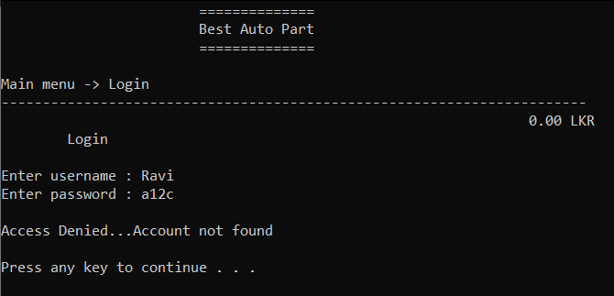

Figure 66 login fail

### Manage login (user)

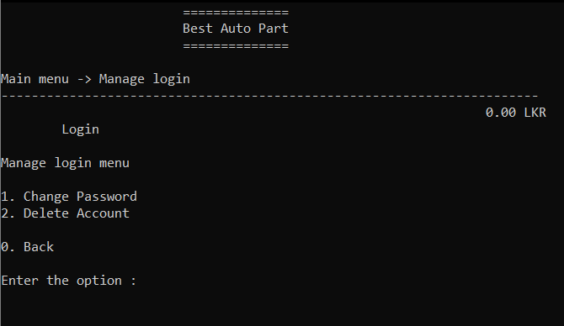

Figure 67 manage login of user

### Manage login (admin)

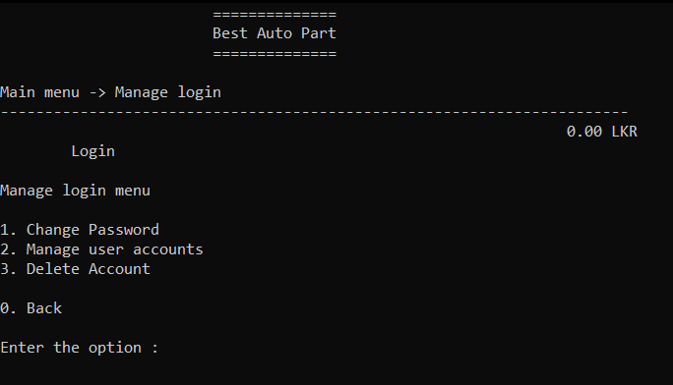

Figure 68 manage login of admin

#### **Change** password

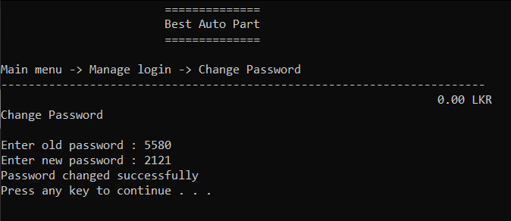

Figure 69 change password

#### **Manage user accounts (admin)**

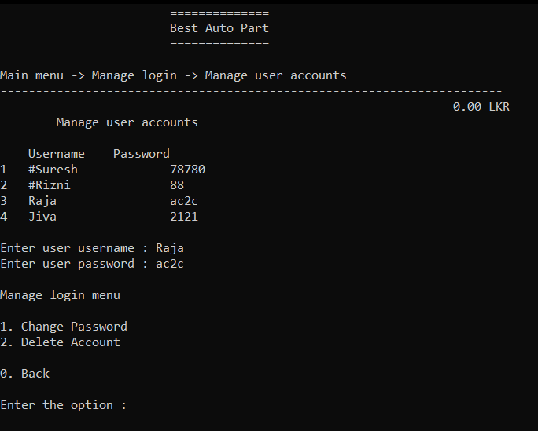

Figure 70 manage user accounts of admin

#### **Delete account**

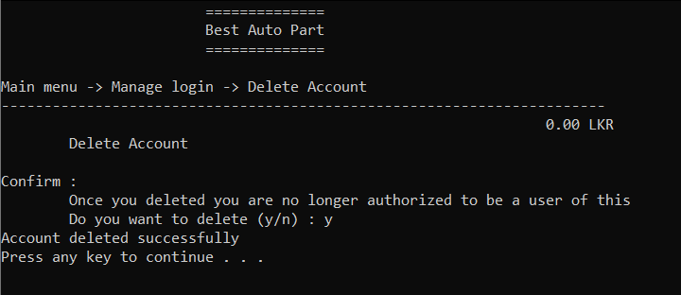

Figure 71 delete account

### Sign up

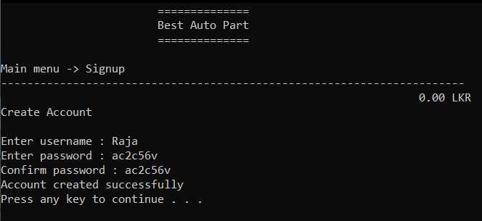

Figure 72 sign up

### Manage services & products

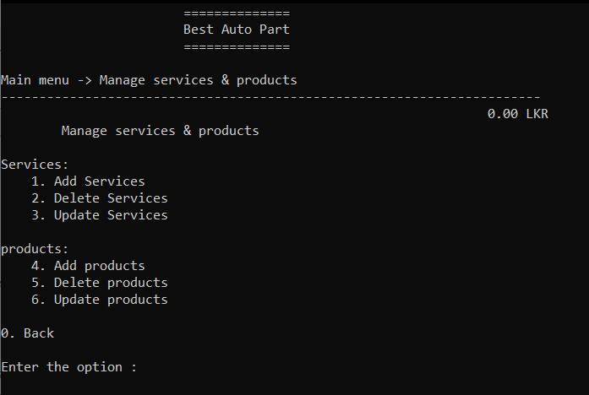

Figure 73 manage services & products

#### **Services:**

##### **Add services**

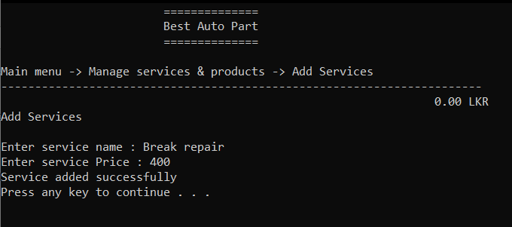

Figure 74 add services

##### **Delete services**

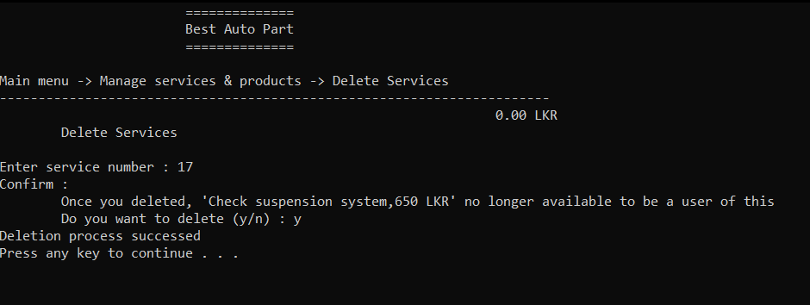

Figure 75 delete services

##### **Update services**

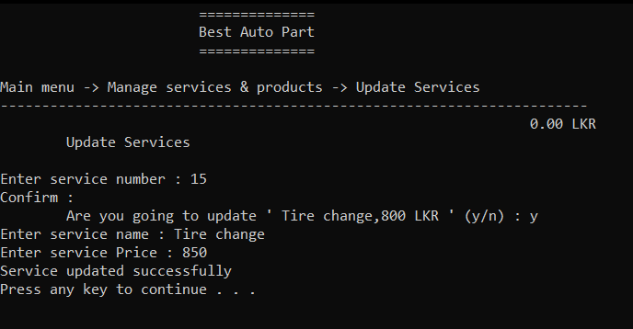

Figure 76 update services

#### **Products:**

##### **Add products**

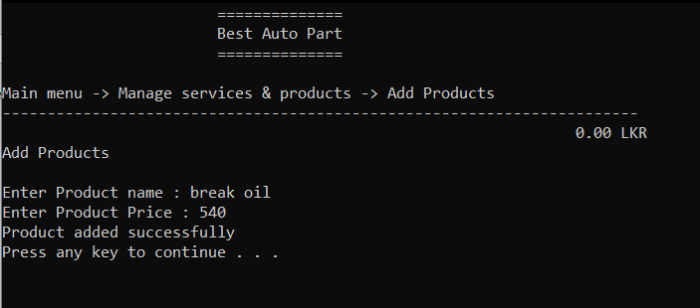

Figure 77 add products

##### **Delete products**

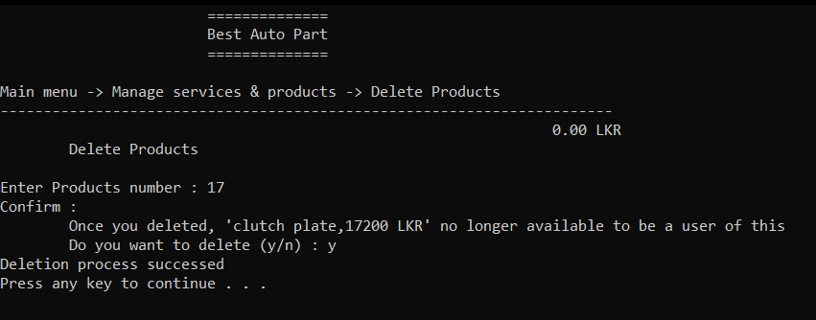

Figure 78 delete products

##### **Update products**

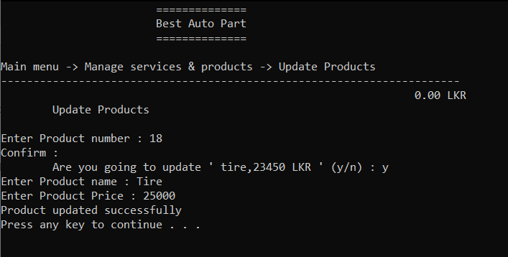

Figure 79 update products

### Available Services (guest)

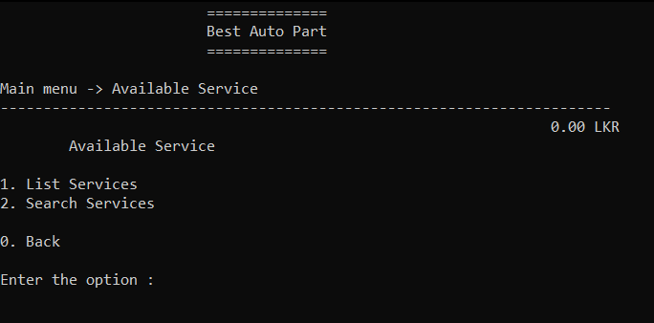

Figure 80 available services of guest

### Available Services (user and admin)

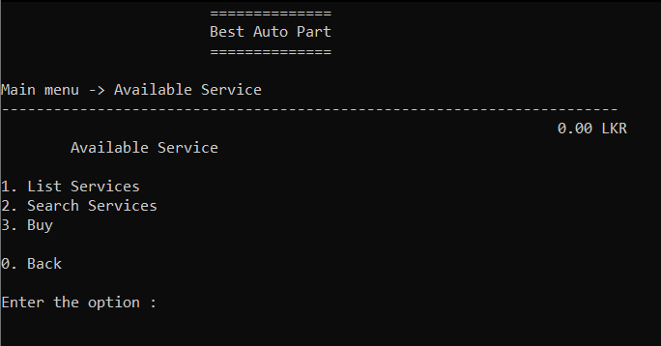

Figure 81 available services of user and admin

#### **List Services**

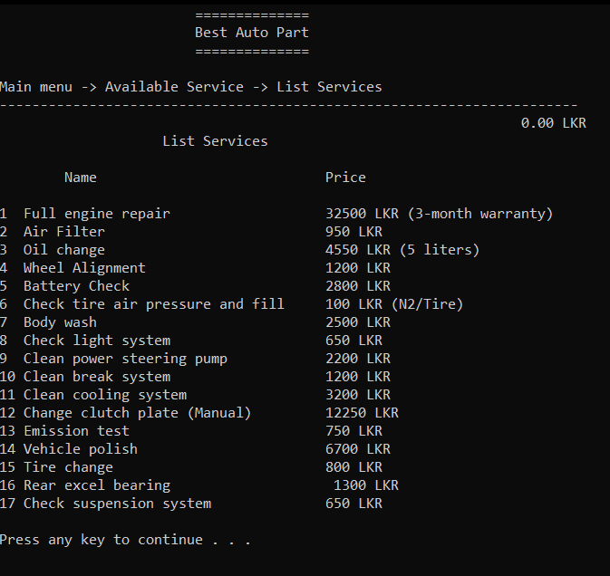

Figure 82 list services

#### **Search Services**

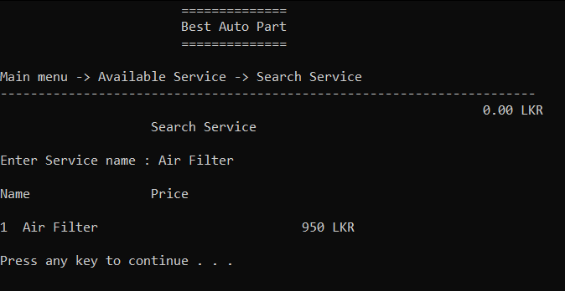

Figure 83 search services

#### Buy (user and admin)

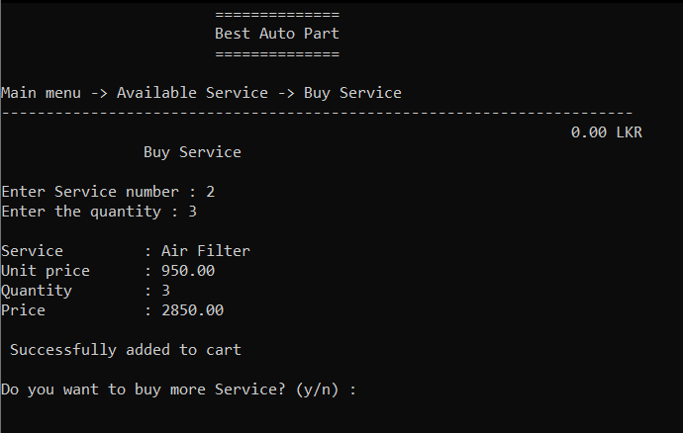

Figure 84 buy service of user and admin

### Available Products (guest)

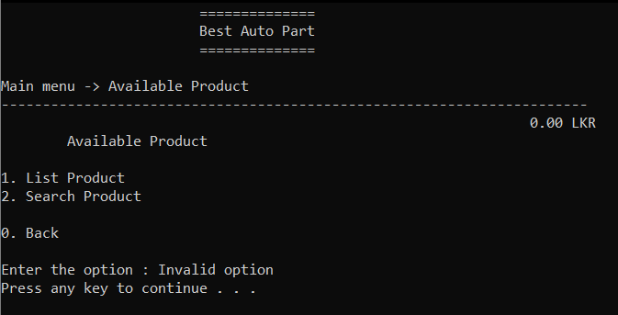

Figure 85 available products of guest

### Available Products (user and admin)

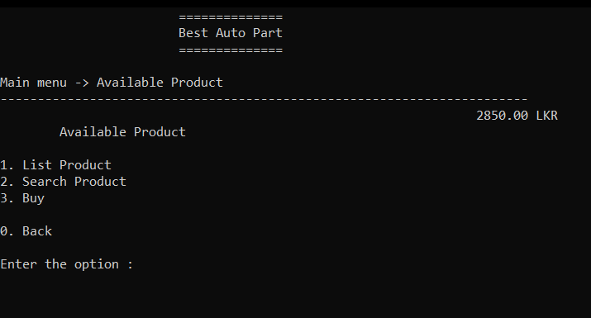

Figure 86 available Products of user and admin

#### List Product

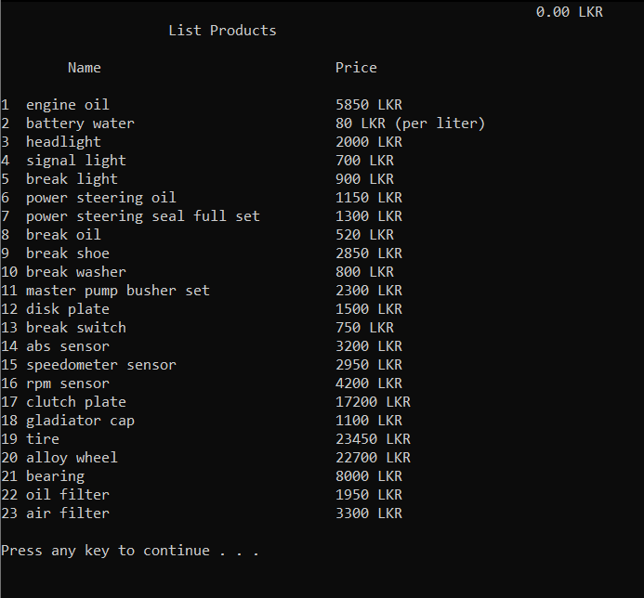

Figure 87 list products

#### Search Product

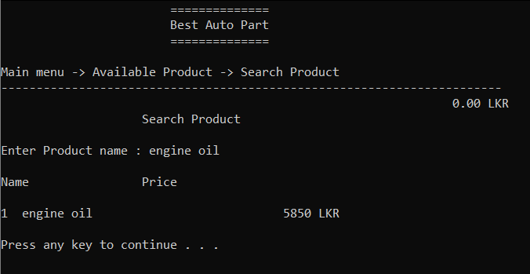

Figure 88 search products

#### Buy (user and admin)

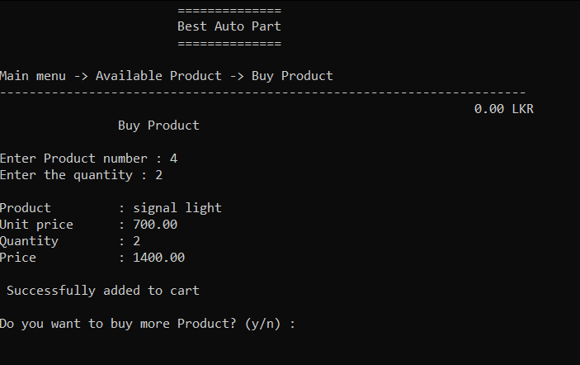

Figure 89 buy product of user and admin

### Cart (user and admin)

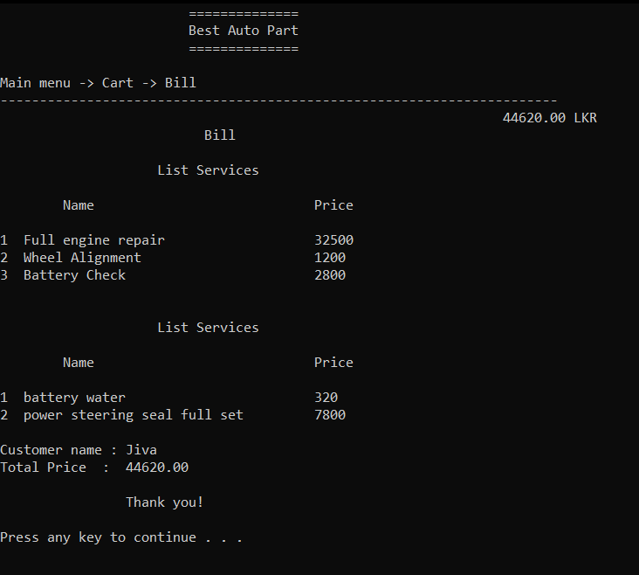

Figure 90 cart of user and admin

# Development

## Introduction

In order to connect clients’ needs with the relevant technical solutions, software engineers engage in the software development life cycle. Thus, processes to provide specific functions are systematically created.

(Software ‘Developer’ or ‘Engineer’: What’s the Difference? — SheCanCode, 2021)

## Development environment

The Hardware and Software configurations that were used for system development have been categorized in the Table 1

|  |  |
| --- | --- |
| Hardware specification | Software specification |
| System Model - Aspire A515-54G | Microsoft Windows 10 Home Single Language |
| RAM 8.00 GB | VS Code V.1.55.2(user setup) |
| 1TB HDD + 256 SSD | Dev C++ V.5.11 |
| Nvidia MX-250 2GB | TDM-GCC Compiler V.4.9.2 |
|  | C++ V.11 |

Table 1 Implantation environment

## System Development Tools and Technologies

### DEV C++

Dev C++ IDE V.5.11 is used to develop entire program in C++.

### VS Code

VS Code IDE V.1.55.2(user setup) is used to test entire program in C++.

### TDM-GCC Compiler

TDM-GCC Compiler V.4.9.2 is used for compiling codes and execute the program.

### C++ V.11

C++ V.11 programming language is used to code entire program

## Hierarchical Function Structure

Hierarchical Function Structure is used to indicate the function groups which helps to understand the code structure.

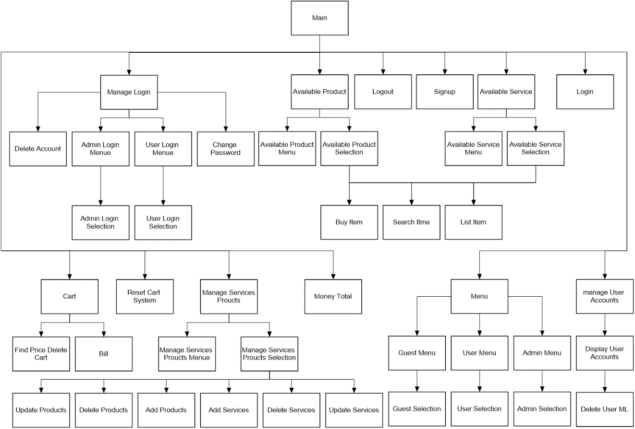

Figure 91 Basic hierarchical Function Structure

## Code Structure

This section describes all major code segments that have been implemented during the Implementation phase to make the intended functionalities of the project a workable and productive solution. Visit below link for all code

<https://drive.google.com/drive/folders/1LB9X_2W0LRUbmnOuZNUEfG52zfzMZbEM?usp=sharing>

### Main requirements

* Manage available services and products (add, delete, update)

#### Products

##### Add

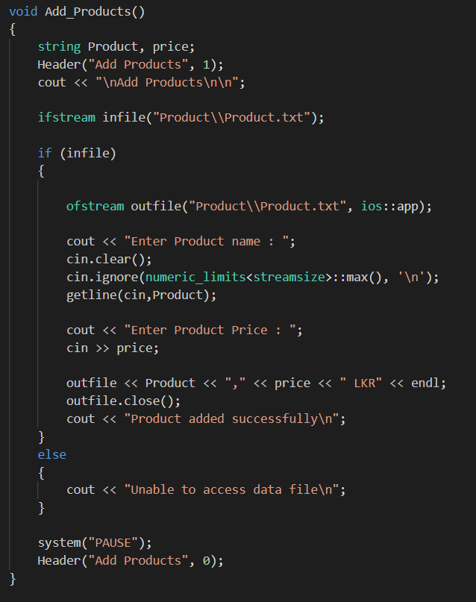

Figure 92 add products

##### Delete

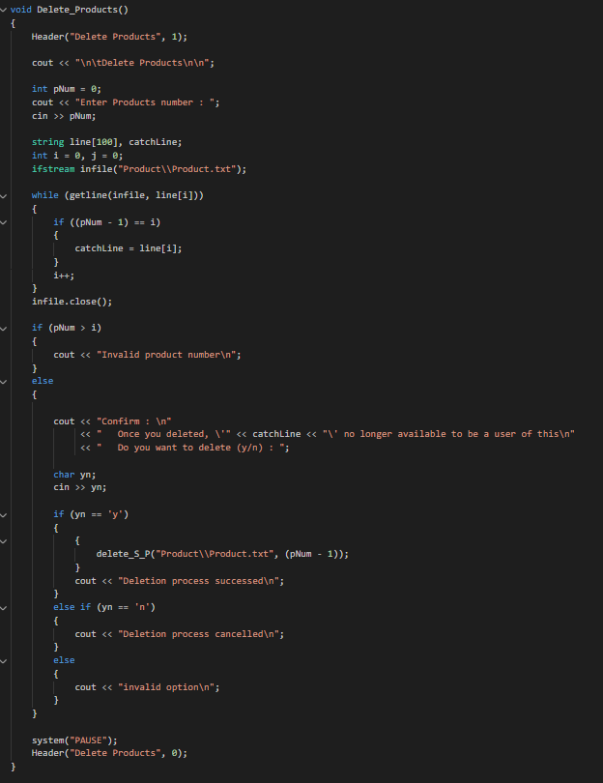

Figure 93 delete products

##### Update

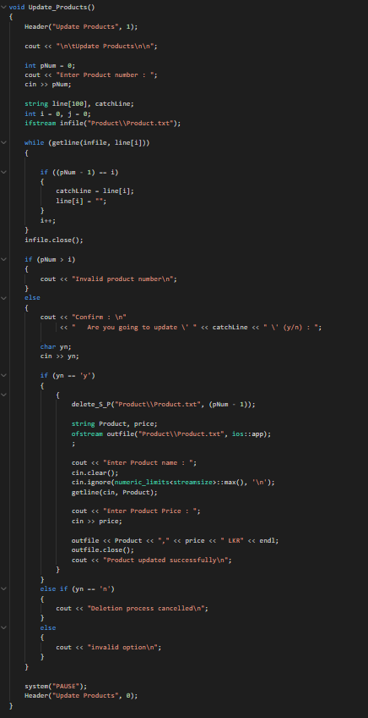

Figure 94 update products

#### Services

##### Add

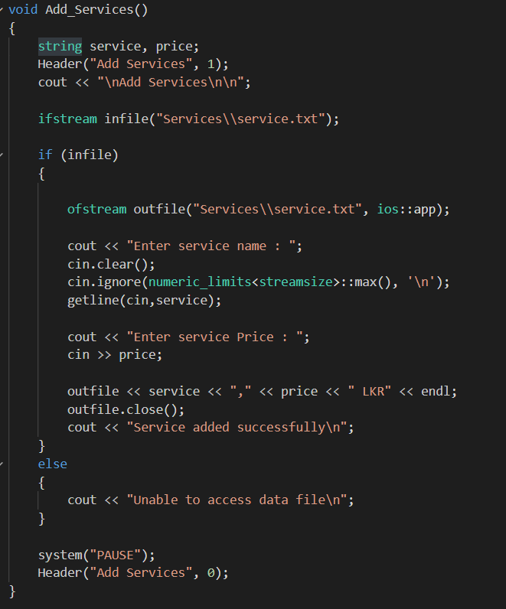

Figure 95 add services

##### Delete

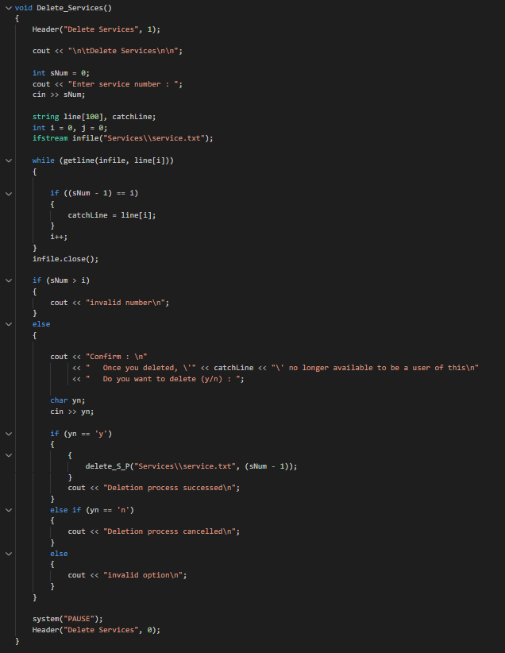

Figure 96 delete services

##### Update

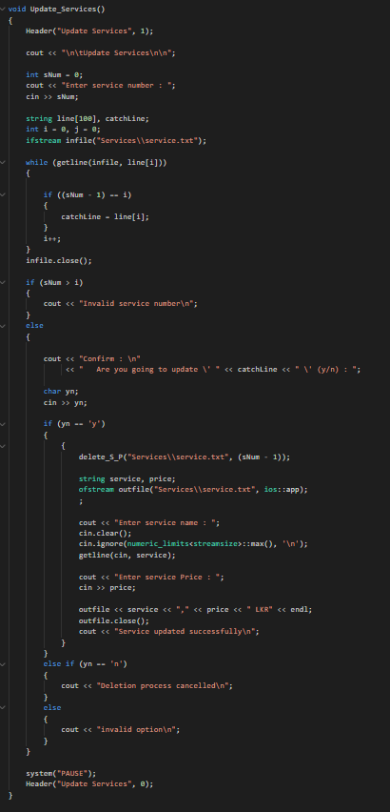

Figure 97 update services

#### List available services and products.

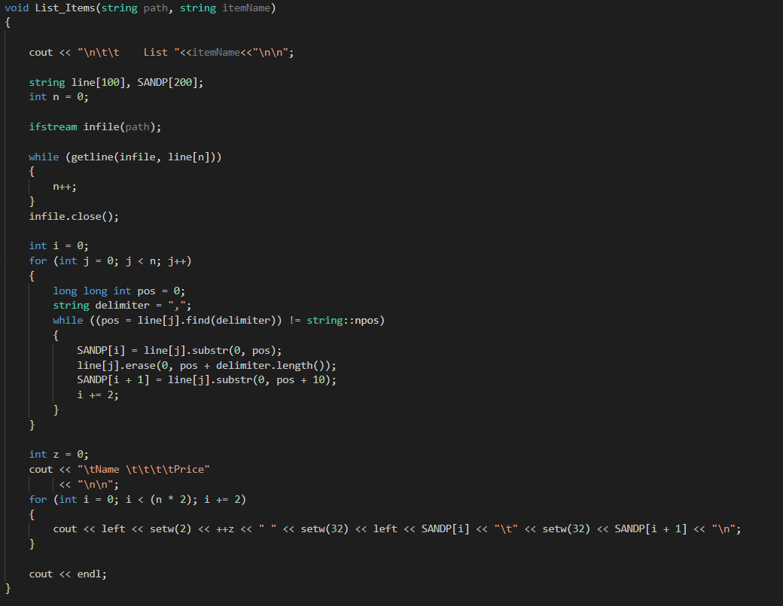

Figure 98 list available services and products

#### Search specific product or service.

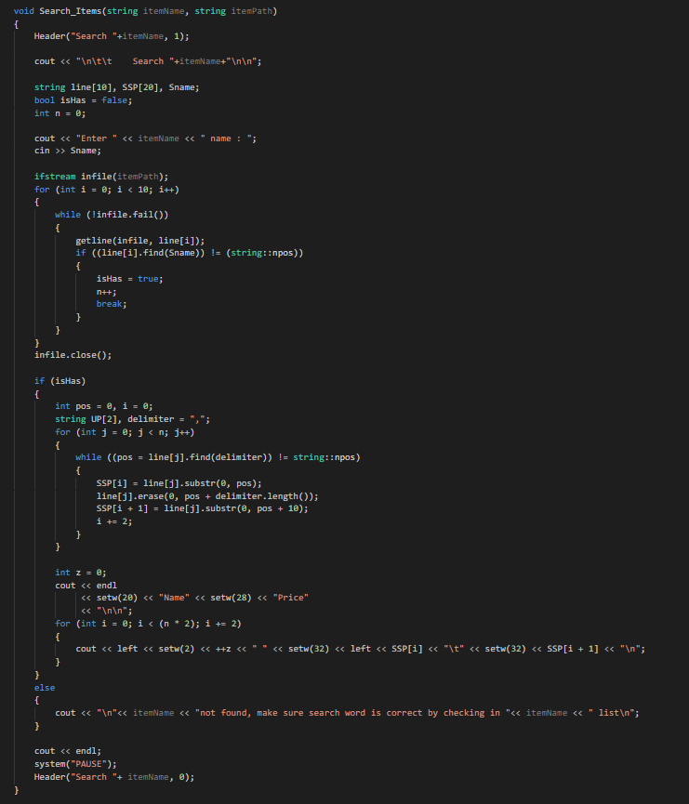

Figure 99 search specific product or service

### Other requirements

#### User login

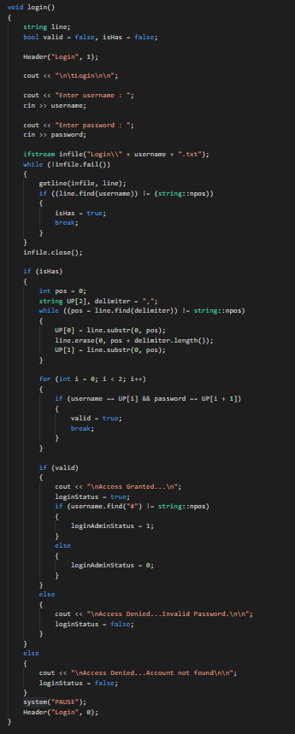

Figure 100 user login

#### Logout

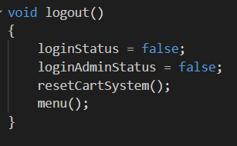

Figure 101 logout

#### Exit

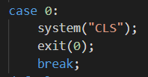

Figure 102 exit

#### Headers

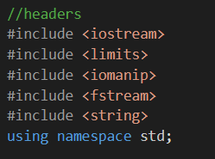

Figure 103 headers

#### Function prototyping

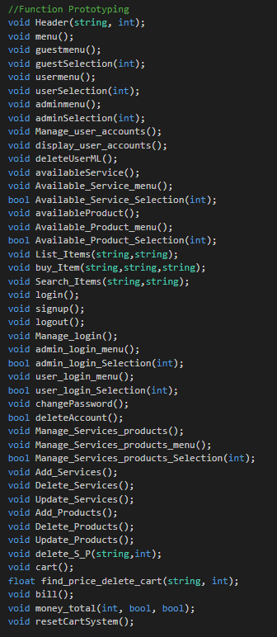

Figure 104 function prototyping

#### Global Variable

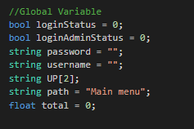

Figure 105 global Variable

#### Main

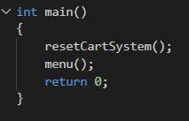

Figure 106 main

#### Reset cart system

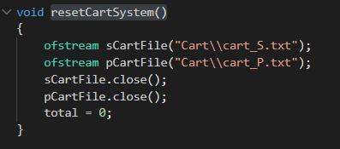

Figure 107 reset cart system

#### Header

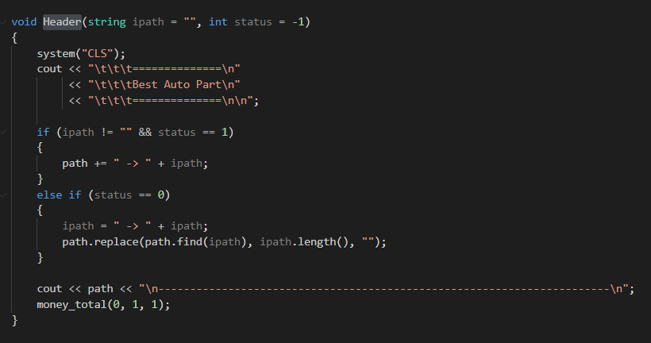

Figure 108 header

#### Money total

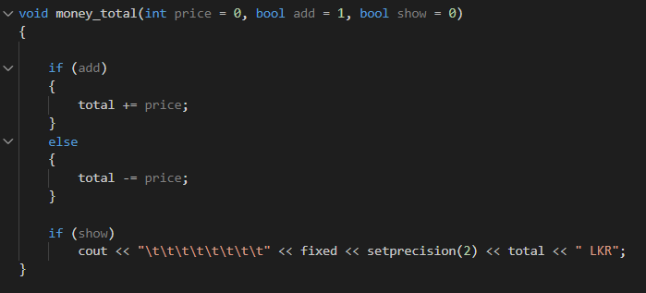

Figure 109 money total

#### Menu

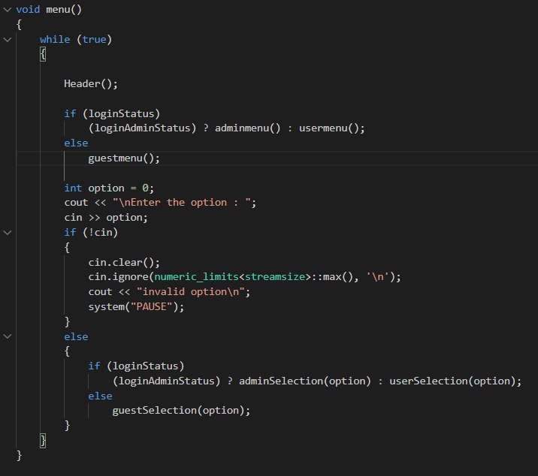

Figure 110 menu

#### Guest menu

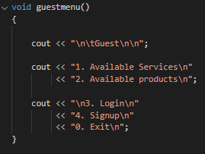

Figure 111 guest menu

#### Guest selection

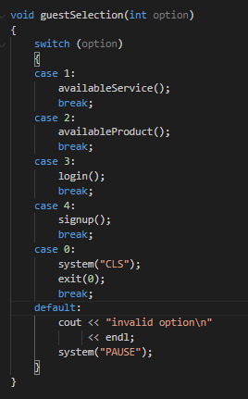

Figure 112 guest selection

#### Available service

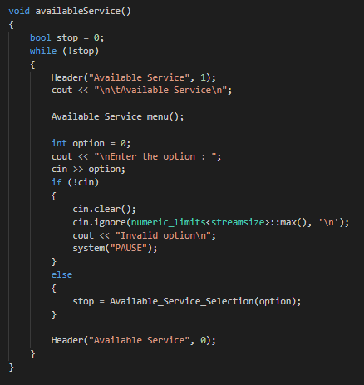

Figure 113 available service

#### Available service menu

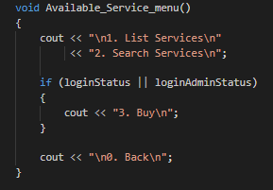

Figure 114 available service menu

#### Available service selection

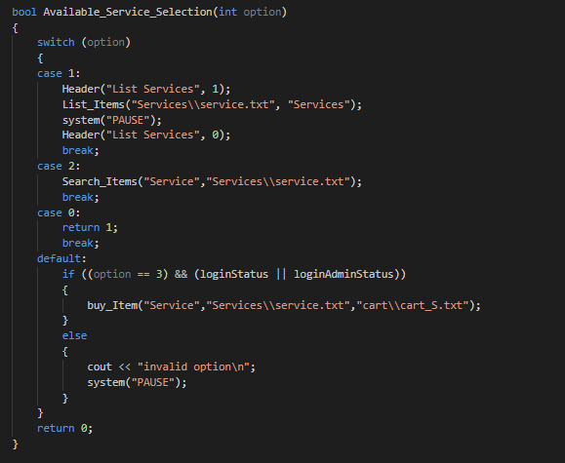

Figure 115 available service selection

#### Buy item

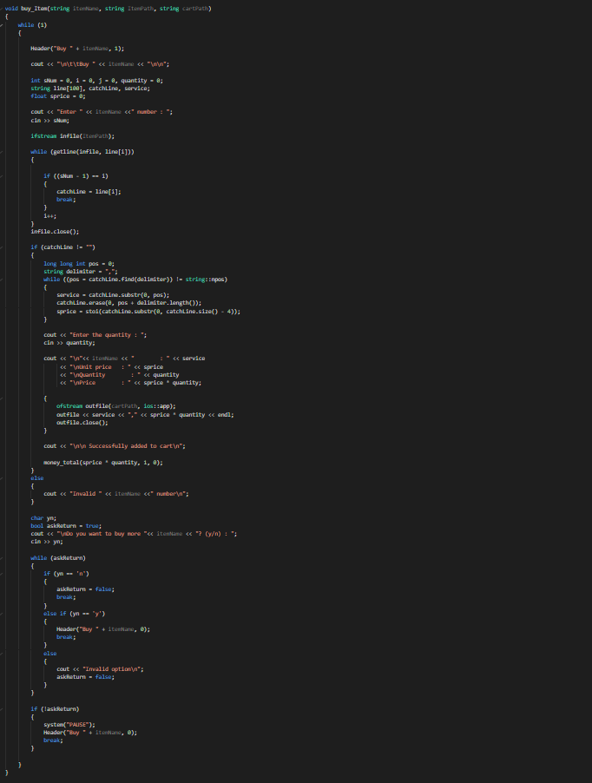

Figure 116 buy item

#### Available product

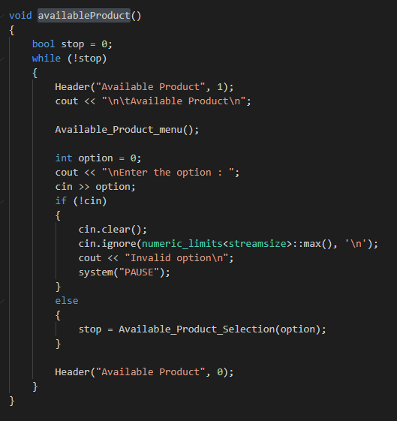

Figure 117 available product

#### Available product menu

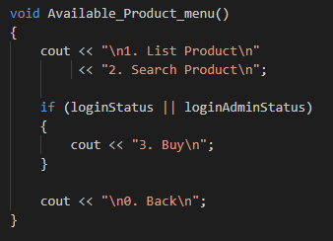

Figure 118 available product menu

#### Available product selection

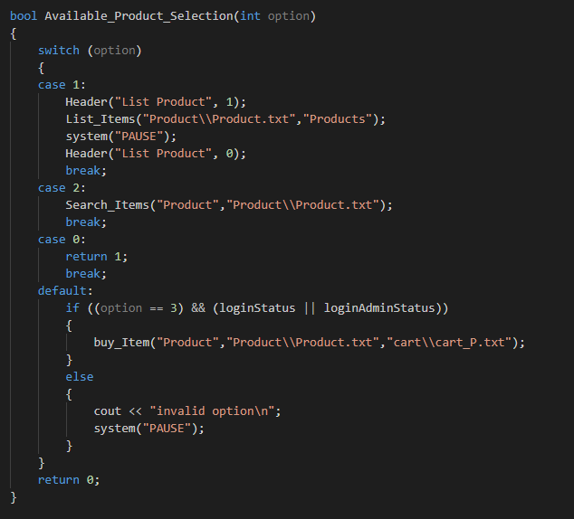

Figure 119 available product selection

#### Admin menu

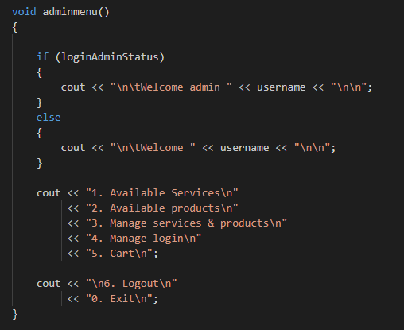

Figure 120 admin menu

#### Admin selection

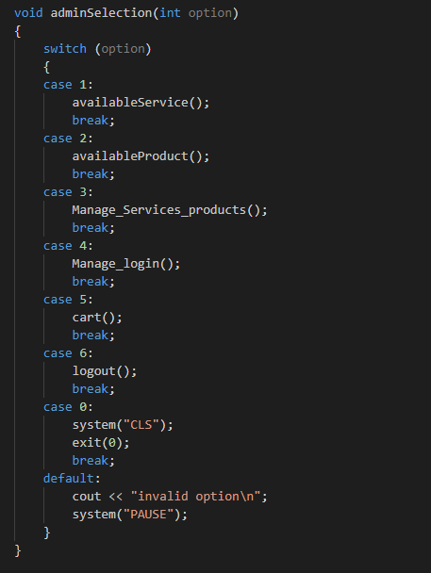

Figure 121 admin selection

#### Manage services products

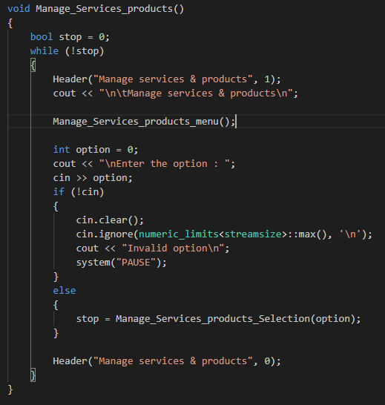

Figure 122 manage services products

#### Manage services products menu

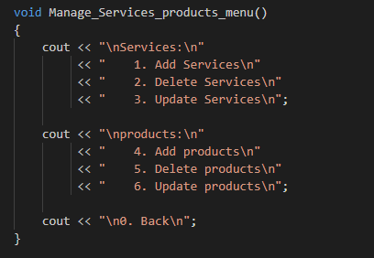

Figure 123 manage services products menu

#### Manage services products selection

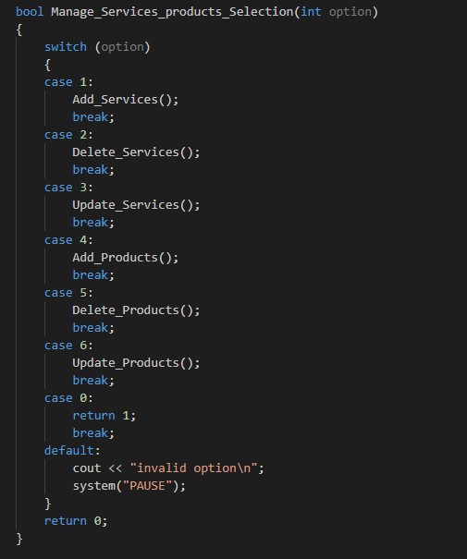

Figure 124 manage services products selection

#### Core function of delete service and product

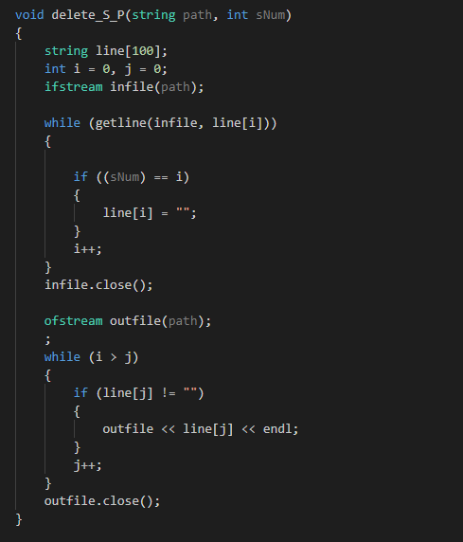

Figure 125 core function of delete service and product

#### User menu

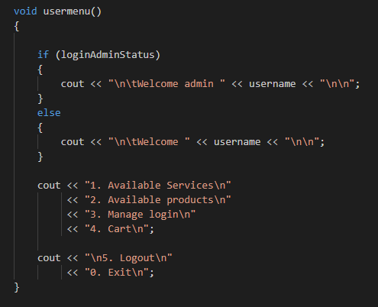

Figure 126 user menu

#### User selection

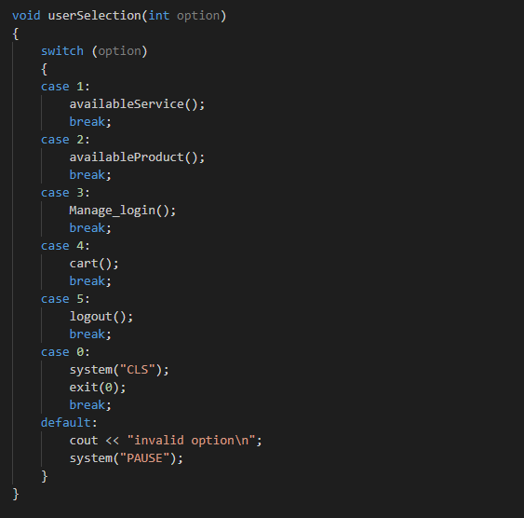

Figure 127 user selection

#### Sign up

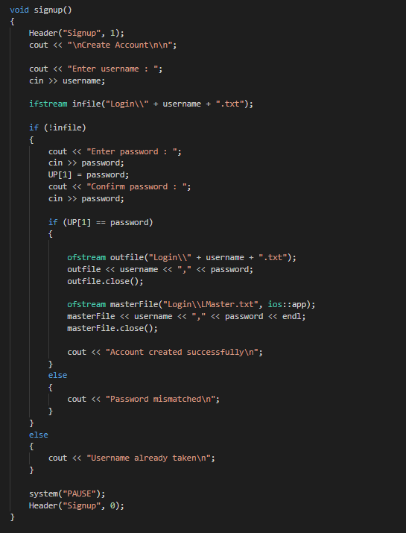

Figure 128 sign up

#### Manage login

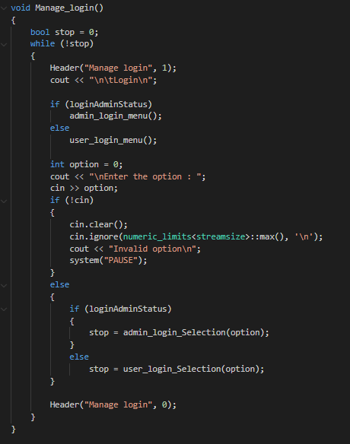

Figure 129 manage login

#### Admin login menu

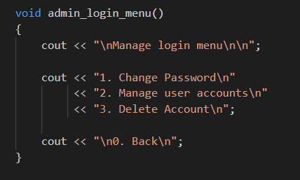

Figure 130 admin login menu

#### Admin login selection

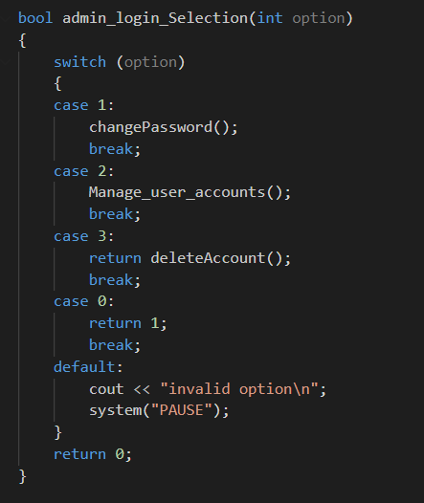

Figure 131 admin login selection

#### User login menu

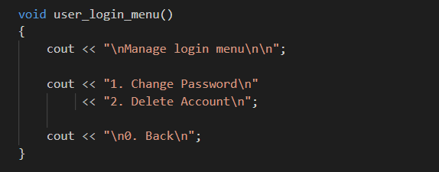

Figure 132 user login menu

#### User login selection

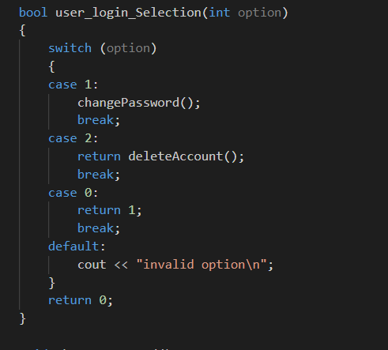

Figure 133 user login selection

#### Change password

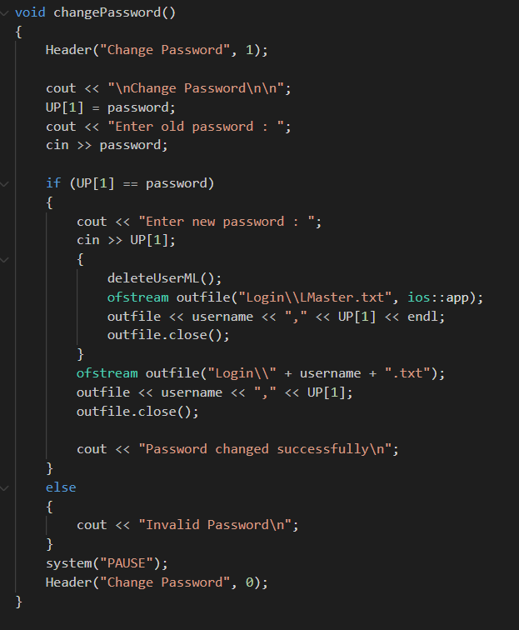

Figure 134 change password

#### Delete account

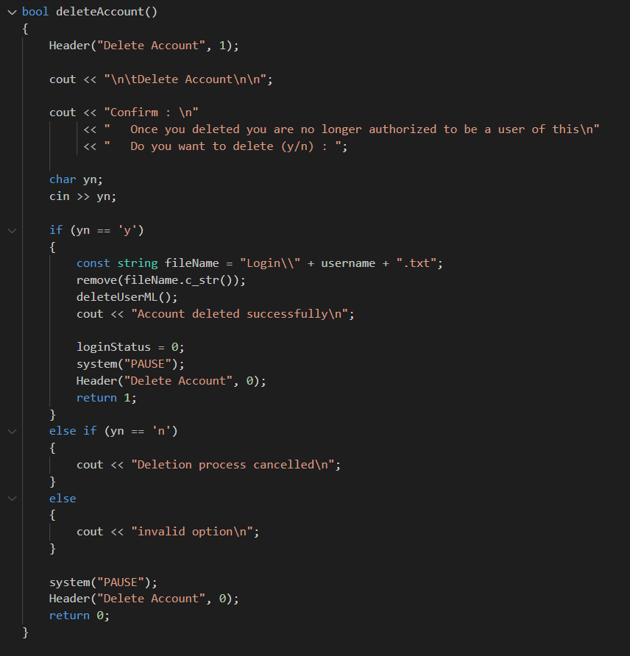

Figure 135 delete account

#### Delete user in master login

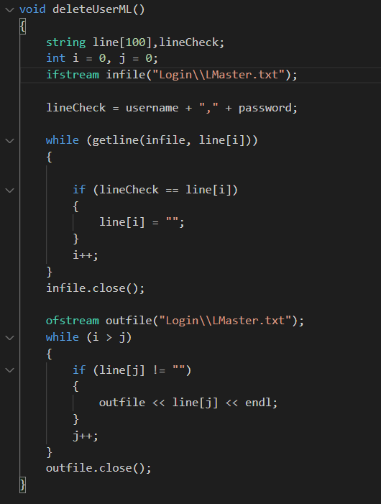

Figure 136 delete user in master login

#### Manage user accounts

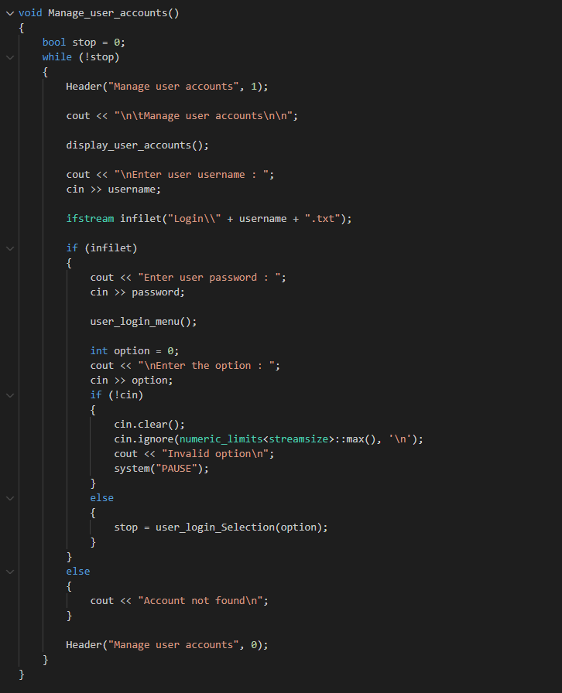

Figure 137 manage user accounts

#### Display user accounts

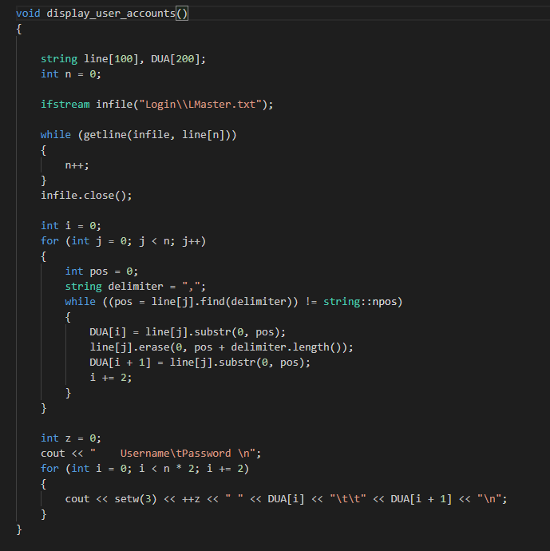

Figure 138 display user accounts

#### Cart

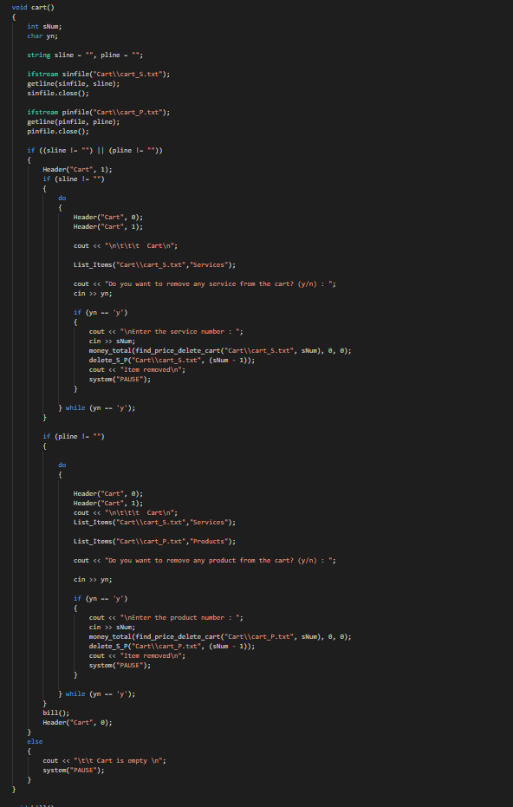

Figure 139 cart

#### Bill

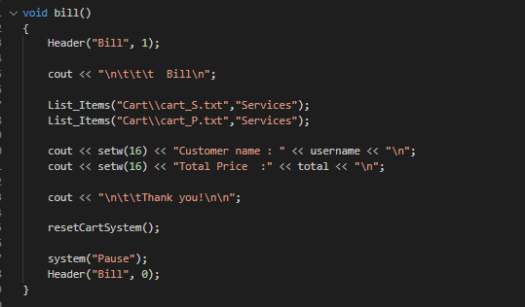

Figure 140 bill

#### Find the price of item in the cart to delete

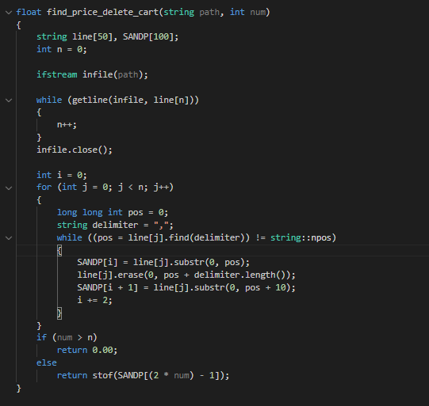

Figure 141 find the price of item in the cart to delete

## Validation

* Page - Main menu

In the main menu, user need to pick an option from displaying menu list. Otherwise, it will throw “Invalid option” message in the display

* Page – Available service

In the Available service menu, user need to pick an option from displaying menu list. Otherwise, it will throw “Invalid option” message in the display

* Page – Search service

In the search service page, user need to enter correct service name or part of name for searching. Otherwise, it will throw “Service not found, make sure search word is correct by checking in Service list” message in the display

* Page – Buy service

In the buy service page, user need to enter correct service number for select service to buy. Otherwise, it will throw “Invalid Service number” message in the display

For answering “Do you want to buy more Service? (y/n) : ” this question, user need to type ‘y’ or ‘n’. Otherwise, it will throw “Invalid option” message in the display

* Page – Available product

In the Available product menu, user need to pick an option from displaying menu list. Otherwise, it will throw “Invalid option” message in the display

* Page – Search product

In the search product page, user need to enter correct product name or part of name for searching. Otherwise, it will throw “Product not found, make sure search word is correct by checking in Product list” message in the display

* Page – Buy product

In the buy product page, user need to enter correct product number for select product to buy. Otherwise, it will throw “Invalid Product number” message in the display

For answering “Do you want to buy more Product? (y/n) : ” this question, user need to type ‘y’ or ‘n’. Otherwise, it will throw “Invalid option” message in the display

* Page - Manage Services & Products

In the Available product menu, user need to pick an option from displaying menu list. Otherwise, it will throw “Invalid option” message in the display

* Page – Delete service

In the delete service, user need to enter correct service number for select service to delete. Otherwise, it will throw “Invalid number” message in the display

* Page – Delete product

In the delete product page, user need to enter correct product number for select product to delete. Otherwise, it will throw “Invalid number” message in the display

* Page – Update services

In the Update Services page, user need to enter correct service number for select service to update. Otherwise, it will throw “Invalid service number” message in the display

For answering “Are you going to update ' <Name>, <Price> LKR ' (y/n) :” this question, user need to type ‘y’ or ‘n’. Otherwise, it will throw “Invalid option” message in the display

* Page – Update product

In the Update product page, user need to enter correct product number for select product to update. Otherwise, it will throw “Invalid product number” message in the display

For answering “Are you going to update ' <Name>, <Price> LKR ' (y/n) :” this question, user need to type ‘y’ or ‘n’. Otherwise, it will throw “Invalid option” message in the display

* Page - Manage login

In the Manage login menu, user need to pick an option from displaying menu list. Otherwise, it will throw “Invalid option” message in the display

* Page - Change password

In the change password page, user need to enter correct old password first. Otherwise, it will throw “Invalid password” message in the display

* Page - Delete account

In the delete account page, for answering “Once you deleted you are no longer authorized to be a user of this system. Do you want to delete (y/n) :” this question, user need to type ‘y’ or ‘n’. Otherwise, it will throw “Invalid option” message in the display

* Page - Manage user accounts

In the Manage user accounts page, user need to enter correct username form list which that need to manage. Otherwise, it won’t accept any data.

* Page - Cart

In the cart page, for answering “Do you want to remove any service from the cart? (y/n) : ” and “Do you want to remove any product from the cart? (y/n) : ” this question, user need to type ‘y’ or ‘n’. Otherwise, it will throw “Invalid option” message in the display

# Evaluation

## Test plan – IEEE 829

### Test Plan Identifier

BAP_001

### References

Software Requirement Specification

### Introduction

This is the master plan for the best auto mart software. In this plan will addressed those are related to vehicle repairing process of best auto mart. The main aim of this plan is ensuring that new computerized system is giving the same level out of current manual system.

This project consists of three level testing plans. Those are unit testing, integrated/system testing and user acceptance testing

The time allocation for this testing phase is 2 months. The user acceptance testing will contain 1 month after installation process on best auto part company

### Test Items

The test items are:

* 1. Navigation header
  2. Program exit
  3. Login
  4. Logout
  5. Menu
  6. Signup
  7. Program exit
  8. List service
  9. Search service
  10. Buy service
  11. List product
  12. Search product
  13. Buy product
  14. Add service
  15. Delete service
  16. update service
  17. Add product
  18. Delete product
  19. Update product
  20. Change password
  21. Delete account
  22. List user accounts
  23. Cart

### Software Risk Issues

Safety and access to the database must be specified and verified.

### Features to be tested

* 1. Login
  2. Logout
  3. Menu
  4. Signup
  5. Program exit
  6. List service
  7. Search service
  8. Buy service
  9. List product
  10. Search product
  11. Buy product
  12. Add service
  13. Delete service
  14. update service
  15. Add product
  16. Delete product
  17. update product
  18. Change password
  19. Delete account
  20. List user accounts
  21. cart

### Features not to be Tested

* 1. Navigation header

It’s low-level risk and non-functional area

* 1. Program exit

Exit program usually possible and it’s handled by operating system

### Approach

A test will include the Unit, System/Integration (combined) and Acceptance tests for the BEST AUTO MART project. It is hoped that for system/integration tests there would be at least one full-time independent test worker. However, it is possible to do most research by the developer with budget restrictions and time limits.

**Unit testing**: The developer will perform UNIT testing, and the programmer must have proof of unit testing (test case list, sample output, data printouts, defect information).

**Integration testing**: integration/system tests are carried out by programmer

User acceptance testing. This project does not have specialized test tools available. After all critical errors have been repaired, programs come into the system/integration test. A software will have up to two major faults until the testing of the program is impeded.

**User acceptance testing**: Acceptance The actual end-users with the developer team leader will conduct testing. The acceptance test will take place for a period of one month after the completion of the System/Integration testing in conjunction with the current manual system operation.

### Item Pass/Fail Criteria

The program should operate as required to achieve all its main features, and the pass percentage of test cases must exceed 95% and no essential bugs must occur.

### Suspension Criteria and Resumption Requirements

If all of the main features are not working or system login problems, the test should be suspended.

### Test Deliverables

* 1. Plan for Acceptance Testing
  2. Test plan System/Integration
  3. Documentation of the unit test schedules and turnover
  4. Prototypes for screens
  5. Mock-up’s study
  6. Reports and summaries of defect/incident
  7. Turnover statistics and test records

### Remaining Test Tasks

|  |  |  |
| --- | --- | --- |
| **TASK** | **Assigned To** | **Status** |
| Plan for Acceptance Testing | Tester | 100% |
| Test plan System/Integration | Tester | 100% |
| Documentation of the unit test schedules and turnover | Tester | 100% |
| Reports and summaries of defect/incident | Tester | 100% |

Table 2 Remaining test task

### Environmental Needs

* 1. Laptop: intel i5 processor, 10th generation, 8gb ram, 2gb nividia graphics, 100gb disk space
  2. Software: VS Code, notepad, chrome, MS word, MS excel
  3. Internet access

### Staffing and Training Needs

It is preferred that there will be at least one (1) full time tester allocated to the project for the system/integration and acceptance testing phases of the project. This will entail appointment of an individual part time at the beginning of the project to assist in assessments etc... And they will be assigned full time about two months into the project.

### Responsibilities

Test plan, Preparation and execution of tests should be carried out by tester.

### Schedule

Start date : 01.03.2021

End date : 30.04.2021

Perform test execution of perform test – man-hours 120,

Reporting the test – man-hours 30

### Planning Risks and Contingencies

The expense can exceed in the event of an erroneous budget estimate. Contingency Plan – Set the scope before test tasks begin and be aware of the project planning and also constantly monitor budgetary estimates.

### Approvals

The project manager should negotiate on project completion and decide the next steps

(Test plan- IEEE829, 2021)

## Test case

A test case for software engineering is a specified input, running conditions, test procedures and anticipated outcomes defining a single test to be performed to accomplish a certain purpose for software testing, such as the exercise of a certain curriculum course or verification of compliance with a particular requirement.

(Test case - Wikipedia, 2021)

### Login

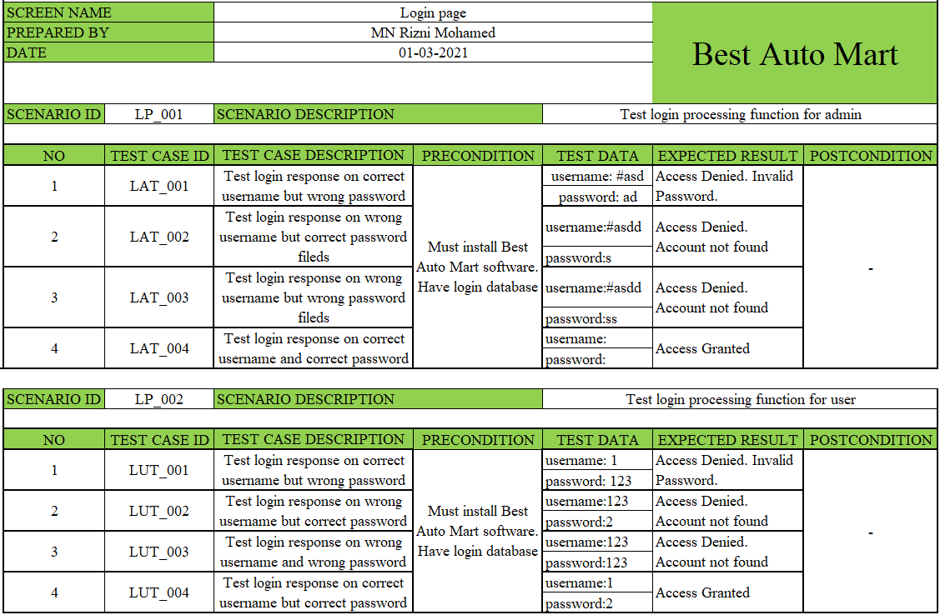

Table 3 Test case Login

|  |  |  |  |  |
| --- | --- | --- | --- | --- |
| No | Test case id | Actual result | Status | Defect id |
| 1 | LAT_001 |  | Pass | - |
|  |
| 2 | LAT_002 |  | Pass | - |  |
|  |
| 3 | LAT_003 |  | Pass |  |  |
|  |
| 4 | LAT_004 |  | Pass |  |  |
|  |

Table 4 Test case login - admin results

|  |  |  |  |  |
| --- | --- | --- | --- | --- |
| No | Test case id | Actual result | Status | Defect id |
| 1 | LUT_001 |  | Pass | - |
|  |
| 2 | LUT_002 |  | Pass | - |  |
|  |
| 3 | LUT_003 |  | Pass |  |  |
|  |
| 4 | LUT_004 |  | Pass |  |  |
|  |

Table 5 Test case login - user results

### Logout

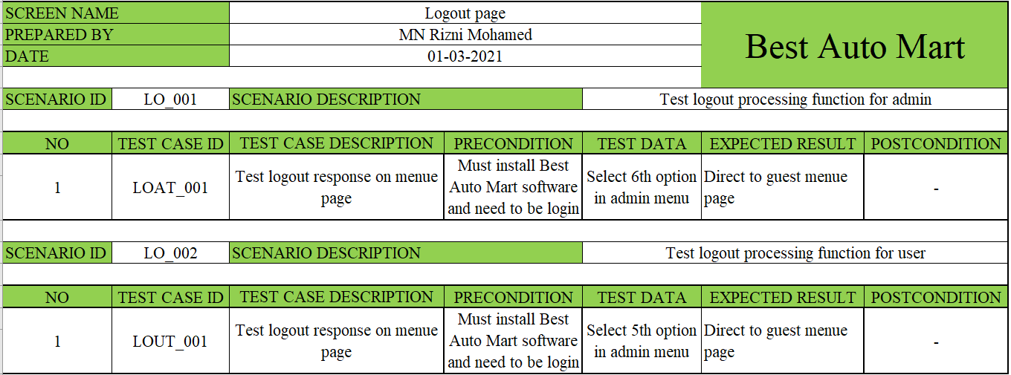

Table 6 Test case logout

|  |  |  |  |  |
| --- | --- | --- | --- | --- |
| No | Test case id | Actual result | Status | Defect id |
| 1 | LOAT_  001 |  | Pass | - |
|  |
|  |

Table 7 Test case logout - admin results

|  |  |  |  |  |
| --- | --- | --- | --- | --- |
| No | Test case id | Actual result | Status | Defect id |
| 1 | LOUT_  001 |  | Pass | - |
|  |
|  |

Table 8 Test case logout - user results

### Menu

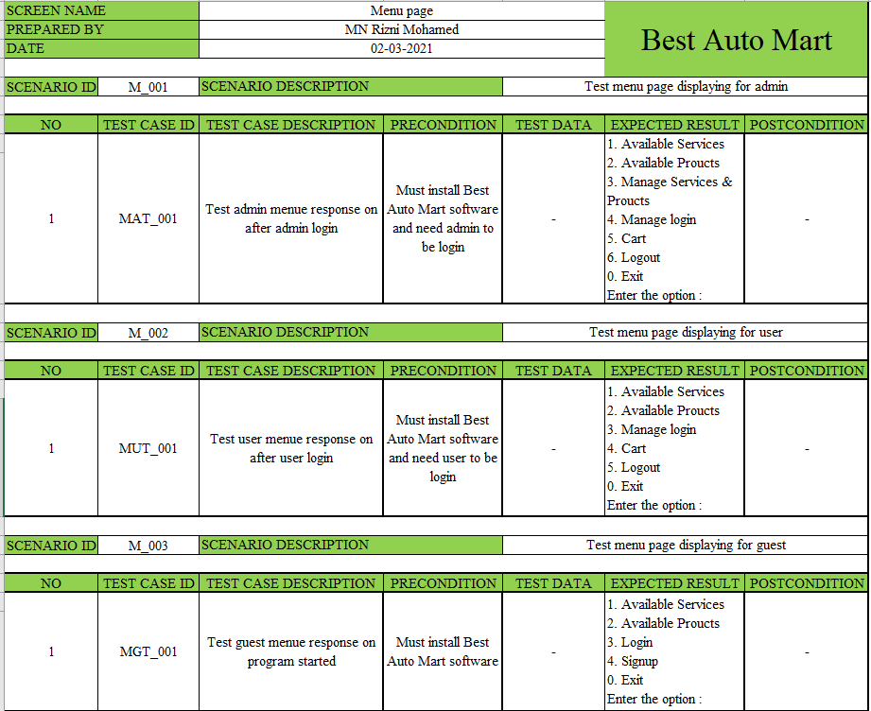

Table 9 Test case menu

|  |  |  |  |  |
| --- | --- | --- | --- | --- |
| No | Test case id | Actual result | Status | Defect id |
| 1 | MAT_  001 |  | Pass | - |
|  |
|  |

Table 10 Test case menu - admin

|  |  |  |  |  |
| --- | --- | --- | --- | --- |
| No | Test case id | Actual result | Status | Defect id |
| 1 | MUT_  001 |  | Pass | - |
|  |
|  |

Table 11 Test case menu - user

|  |  |  |  |  |
| --- | --- | --- | --- | --- |
| No | Test case id | Actual result | Status | Defect id |
| 1 | MGT_  001 |  | Pass | - |
|  |
|  |

Table 12 Test case menu - guest

### Signup

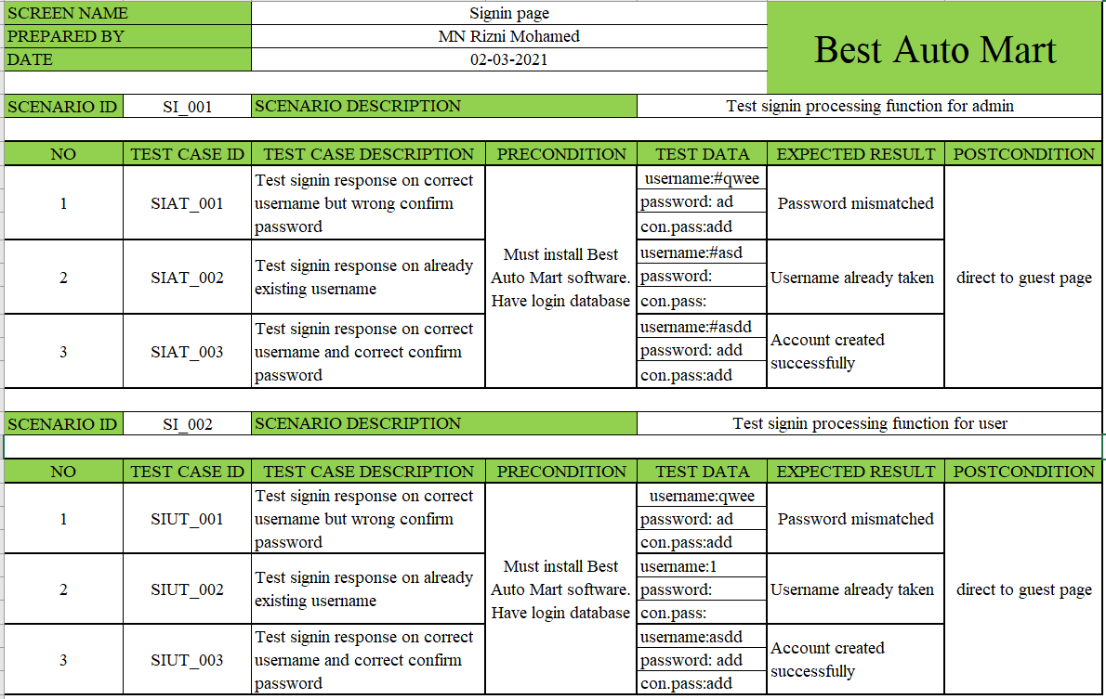

Table 13 Test case signup

|  |  |  |  |  |
| --- | --- | --- | --- | --- |
| No | Test case id | Actual result | Status | Defect id |
| 1 | SIAT  _001 |  | Pass | - |
|  |
| 2 | SIAT  _002 |  | Pass | - |  |
|  |
| 3 | SIAT  _003 |  | Pass |  |  |
|  |
|  |

Table 14 Test case signup - admin

|  |  |  |  |  |
| --- | --- | --- | --- | --- |
| No | Test case id | Actual result | Status | Defect id |
| 1 | SIUT  _001 |  | Pass | - |
|  |
| 2 | SIUT  _002 |  | Pass | - |  |
|  |
| 3 | SIUT  _003 |  | Pass |  |  |
|  |
|  |

Table 15 Test case signup - user

### Program exit

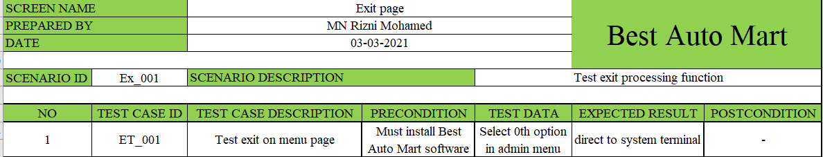

Table 16 Test case program exit

|  |  |  |  |  |
| --- | --- | --- | --- | --- |
| No | Test case id | Actual result | Status | Defect id |
| 1 | ET_001 |  | Pass | - |
|  |
|  |

Table 17 Test case program exit result

### List service

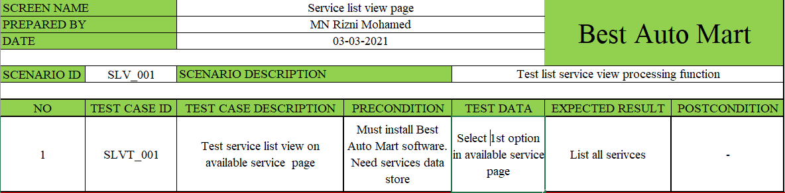

Table 18 Test case list service

|  |  |  |  |  |
| --- | --- | --- | --- | --- |
| No | Test case id | Actual result | Status | Defect id |
| 1 | LVT_001 |  | Pass | - |
|  |
|  |

Table 19 Test case list view result

### Search service

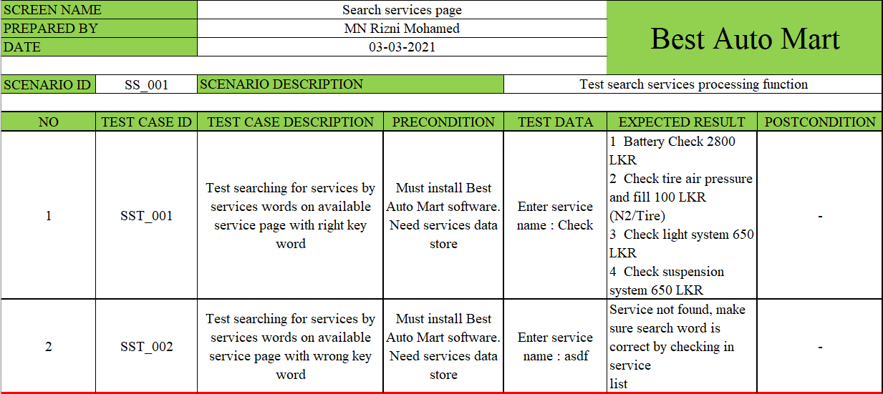

Table 20 Test case search service

|  |  |  |  |  |
| --- | --- | --- | --- | --- |
| No | Test case id | Actual result | Status | Defect id |
| 1 | SST_001 |  | Pass | - |
|  |
|  |
| 2 | SST_002 |  | Pass | - |
|  |
|  |

Table 21 Test case search service results

### Buy service

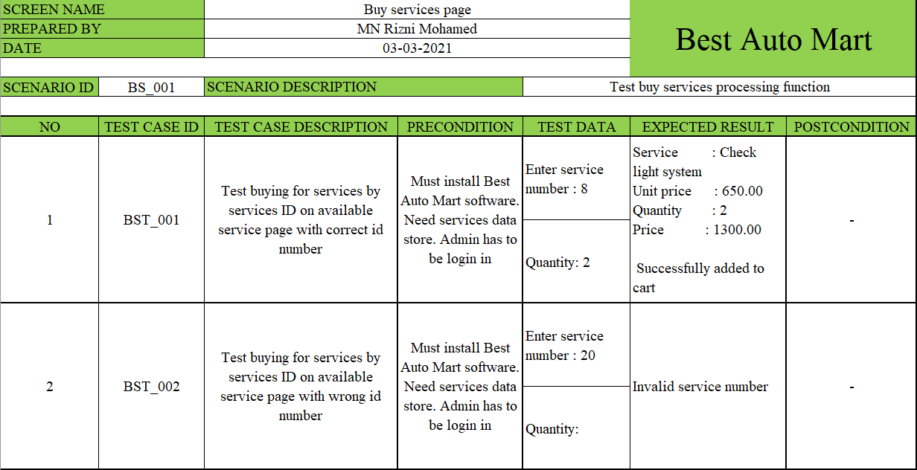

Table 22 Test case buy service

|  |  |  |  |  |
| --- | --- | --- | --- | --- |
| No | Test case id | Actual result | Status | Defect id |
| 1 | BST_001 |  | Pass | - |
|  |
|  |
| 2 | BST_002 |  | Pass | - |
|  |
|  |

Table 23 Test case buy service result

### List product

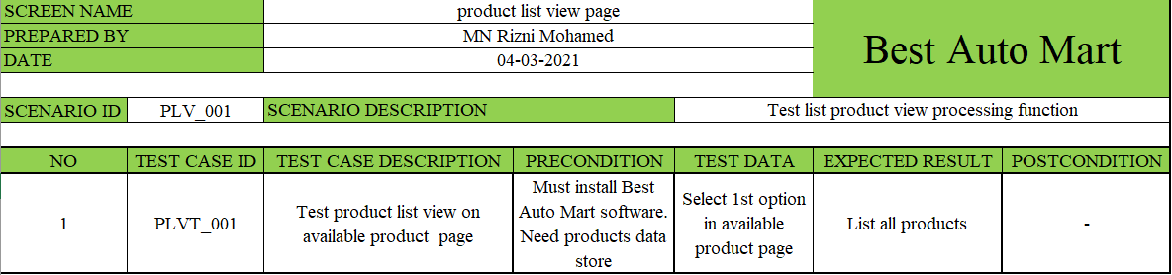

Table 24 Test case list product

|  |  |  |  |  |
| --- | --- | --- | --- | --- |
| No | Test case id | Actual result | Status | Defect id |
| 1 | PLVT  _001 |  | Pass | - |
|  |
|  |

Table 25 Test case list product result

### Search product

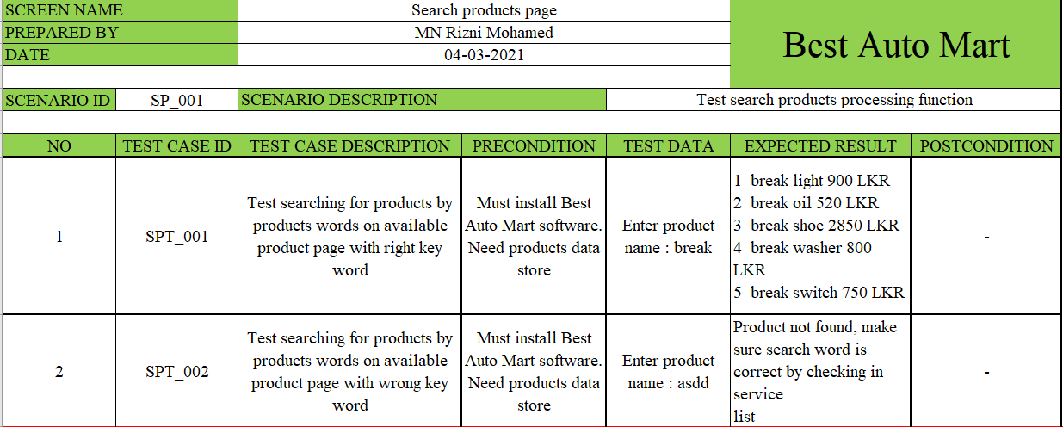

Table 26 Test case search product

|  |  |  |  |  |
| --- | --- | --- | --- | --- |
| No | Test case id | Actual result | Status | Defect id |
| 1 | SPT_001 |  | Pass | - |
|  |
|  |
| 2 | SPT_002 |  | Pass | - |
|  |
|  |

Table 27 Test case search product results

### Buy product

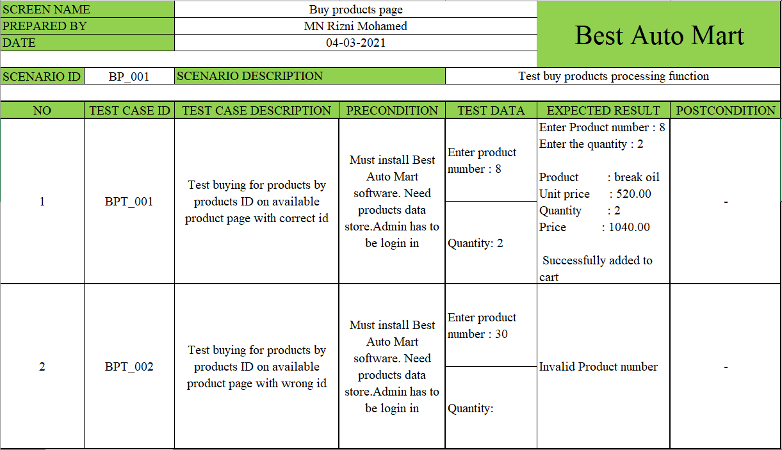

Table 28 Test case buy product

|  |  |  |  |  |
| --- | --- | --- | --- | --- |
| No | Test case id | Actual result | Status | Defect id |
| 1 | BPT_001 |  | Pass | - |
|  |
|  |
| 2 | BPT_002 |  | Pass | - |
|  |
|  |

Table 29 Test case buy product result

### Add service

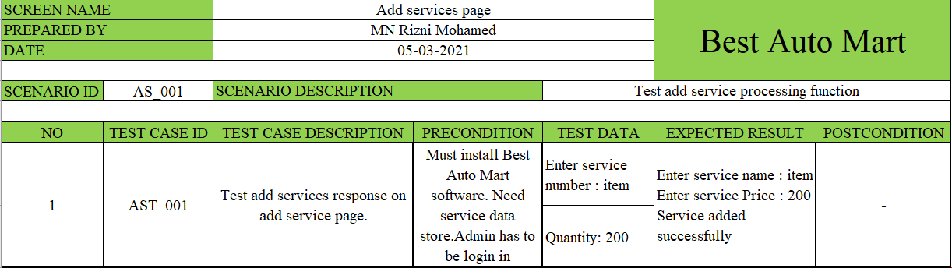

Table 30 Test case add service

|  |  |  |  |  |
| --- | --- | --- | --- | --- |
| No | Test case id | Actual result | Status | Defect id |
| 1 | AST_001 |  | Pass | - |
|  |
|  |

Table 31 Test case add service result

### Delete service

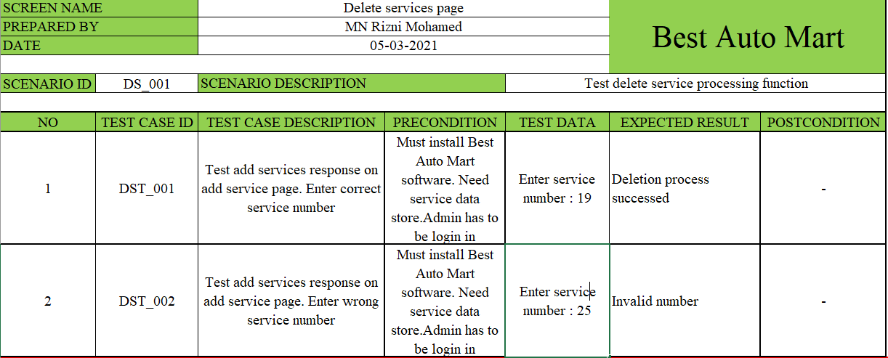

Table 32 Test case Delete service

|  |  |  |  |  |
| --- | --- | --- | --- | --- |
| No | Test case id | Actual result | Status | Defect id |
| 1 | DST_001 |  | Pass | - |
|  |
|  |
| 2 | DST_002 |  | Pass | - |
|  |
|  |

Table 33 Test case Delete service results

### Update service

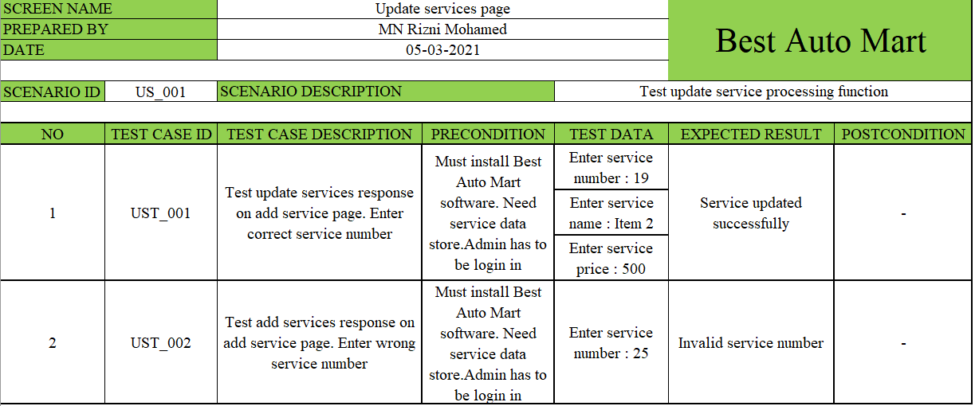

Table 34 Test case Update service

|  |  |  |  |  |
| --- | --- | --- | --- | --- |
| No | Test case id | Actual result | Status | Defect id |
| 1 | UST_001 |  | Pass | - |
|  |
|  |
| 2 | UST_002 |  | Pass | - |
|  |
|  |

Table 35 Test case Update service result

### Add product

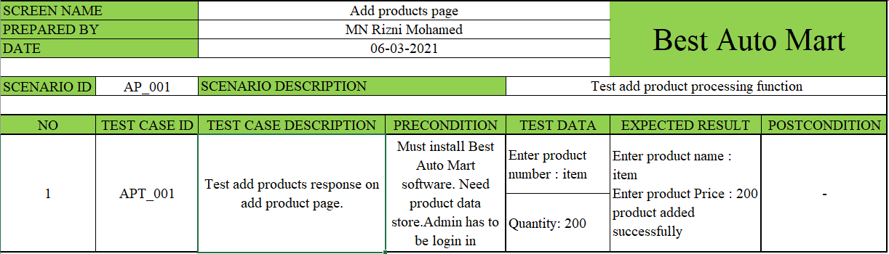

Table 36 Test case add product

|  |  |  |  |  |
| --- | --- | --- | --- | --- |
| No | Test case id | Actual result | Status | Defect id |
| 1 | APT_001 |  | Pass | - |
|  |
|  |

Table 37 Test case add product

### Delete product

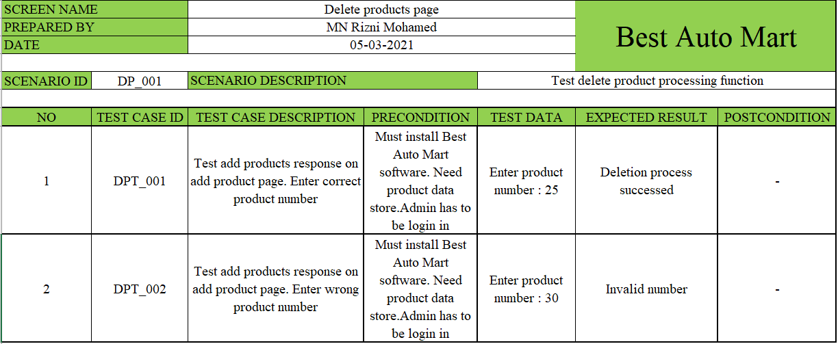

Table 38 Test case delete product

|  |  |  |  |  |
| --- | --- | --- | --- | --- |
| No | Test case id | Actual result | Status | Defect id |
| 1 | DPT_001 |  | Pass | - |
|  |
|  |
| 2 | DPT_002 |  | Pass | - |
|  |
|  |

Table 39 Test case delete product

### Update product

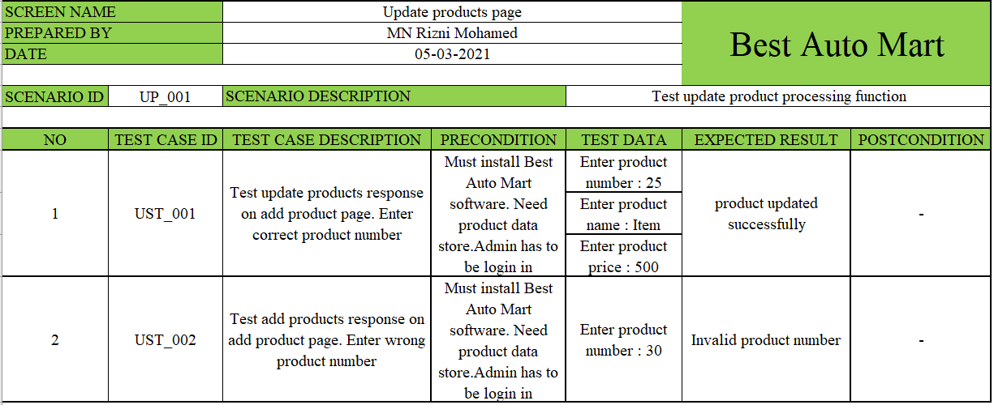

Table 40 Test case update product

|  |  |  |  |  |
| --- | --- | --- | --- | --- |
| No | Test case id | Actual result | Status | Defect id |
| 1 | UPT_001 |  | Pass | - |
|  |
|  |
| 2 | UPT_002 |  | Pass | - |
|  |
|  |

Table 41 Test case update product results

### Change password

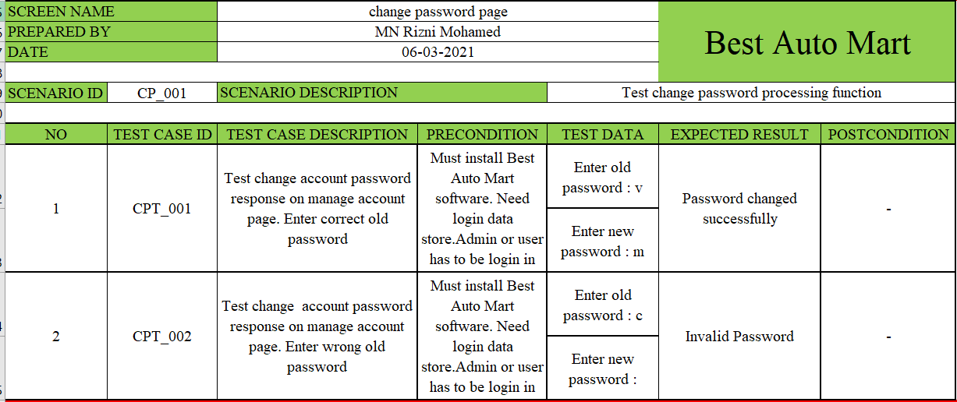

Table 42 Test case change password

|  |  |  |  |  |
| --- | --- | --- | --- | --- |
| No | Test case id | Actual result | Status | Defect id |
| 1 | CPT_001 |  | Pass | - |
|  |
|  |
| 2 | CPT_002 |  | Pass | - |
|  |
|  |

Table 43 Test case change password result

### Delete account

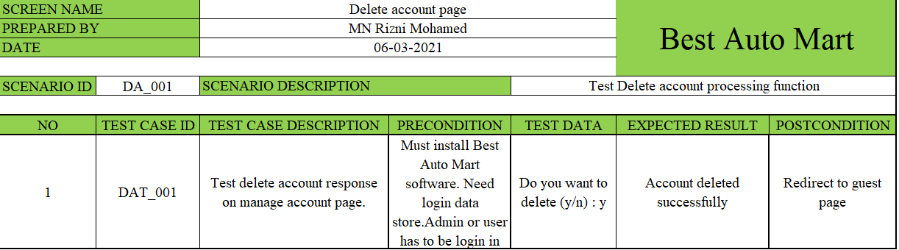

Table 44 Test case delete account

|  |  |  |  |  |
| --- | --- | --- | --- | --- |
| No | Test case id | Actual result | Status | Defect id |
| 1 | DAT  _001 |  | Pass | - |
|  |
|  |
|  |
|  |

Table 45 Test case delete account results

### List user accounts

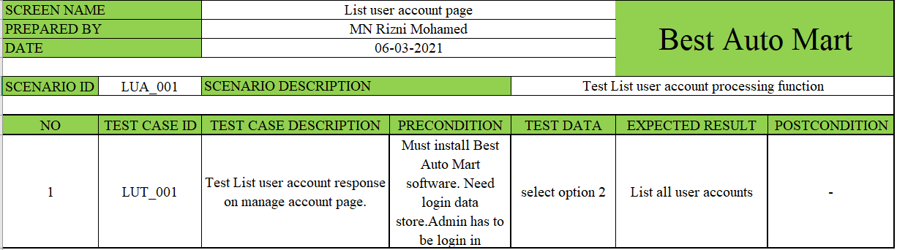

Table 46 Test case list user accounts

|  |  |  |  |  |
| --- | --- | --- | --- | --- |
| No | Test case id | Actual result | Status | Defect id |
| 1 | LUT  _001 |  | Pass | - |
|  |
|  |
|  |
|  |

Table 47 Test case list user accounts results

### Cart

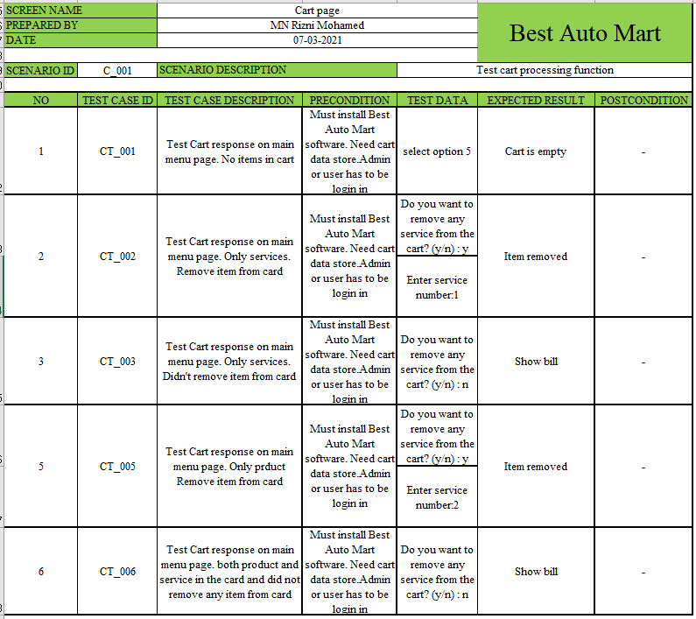

Table 48 Test case cart

|  |  |  |  |  |
| --- | --- | --- | --- | --- |
| No | Test case id | Actual result | Status | Defect id |
| 1 | CT_001 |  | Pass | - |
|  |
|  |
|  |
|  |
| 2 | CT_002 |  | Pass | - |
|  |
|  |
|  |
|  |
| 3 | CT_003 |  | Pass | - |
|  |
|  |
|  |
|  |
| 4 | CT_004 |  | Pass | - |
|  |
|  |
|  |
|  |
| 5 | CT_005 |  | Pass | - |
|  |
|  |
|  |
|  |
| 6 | CT_006 |  | Pass | - |
|  |
|  |
|  |
|  |

Table 49 Test case cart results

## Test summery report

Test Summary Report (TSR) is an essential deliverable that is generated at the conclusion of or after testing. But a consolidated update on the testing carried out on the project so far is included in the test summary report.

(Test summery report - softwaretestinghelp, 2021)

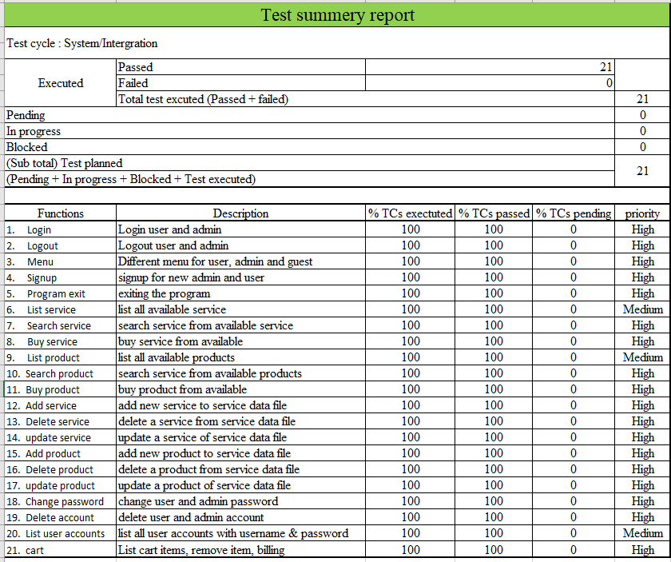

Table 50 Test summery report

## User Accepting Testing (UAT)

After completing the implementation work, the system was installed at the clients’ location in order to go through the user acceptance testing process. The objective was to perform user acceptance testing with the help from potential users during a certain period of time. The user who has administrative privileges completed end to end testing of the system and some system defects were identified during the testing. Those identified defects were fixed and the fixed issues were successfully got verified by administrative user again. The billing functions are tested by the potential users from accounts department of BAM. The functionalities dedicated for users’ level were successfully tested by few users from the BAM company.

At the final stage of the user acceptance testing, the comments and feedback about the new system were collected from users by presenting an evaluation questionnaire form. Some feedback comments received from a user.

### Sample questionnaire

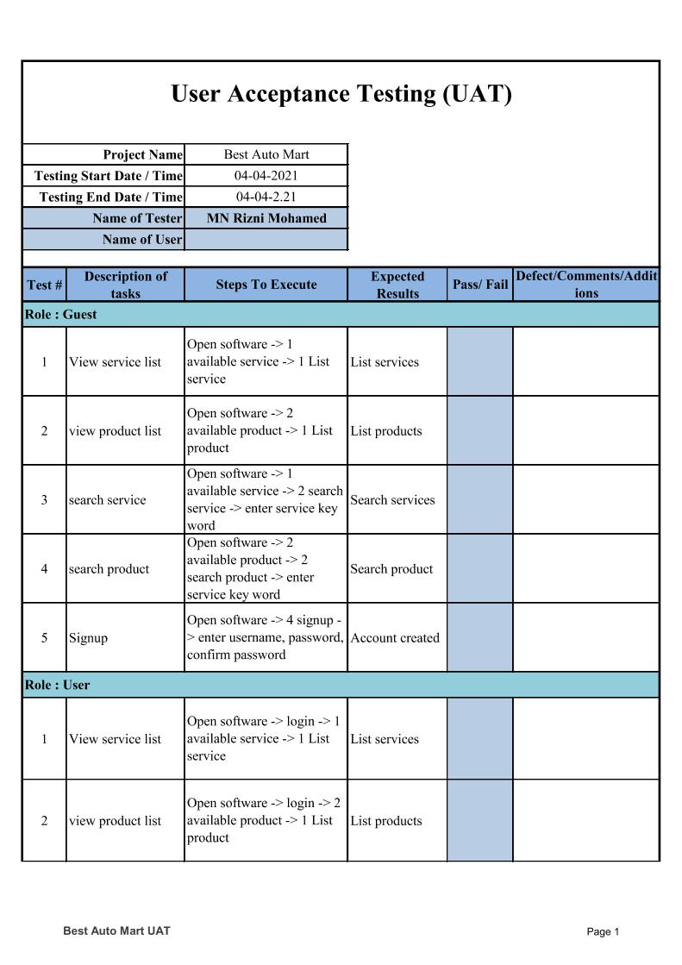

Figure 142 UAT sample questionnaire page 1

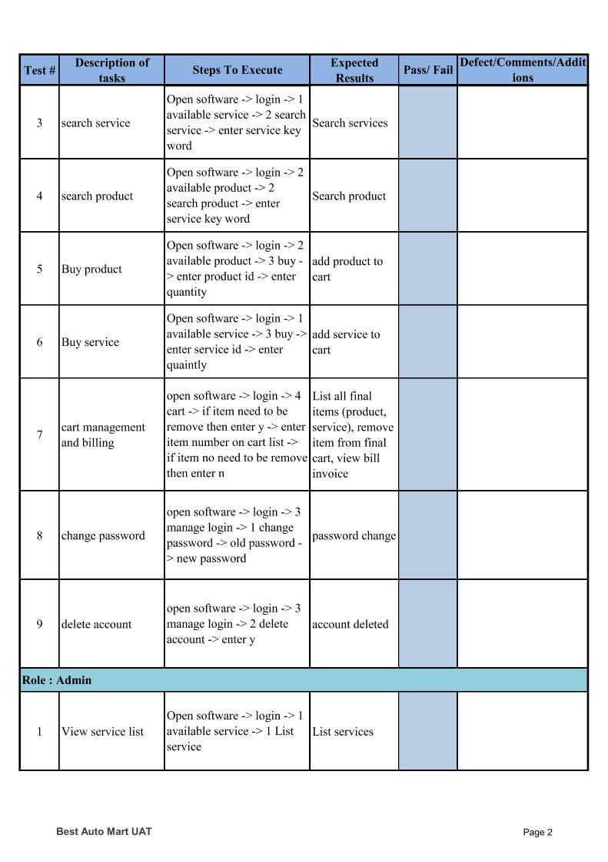

Figure 143 UAT sample questionnaire page 2

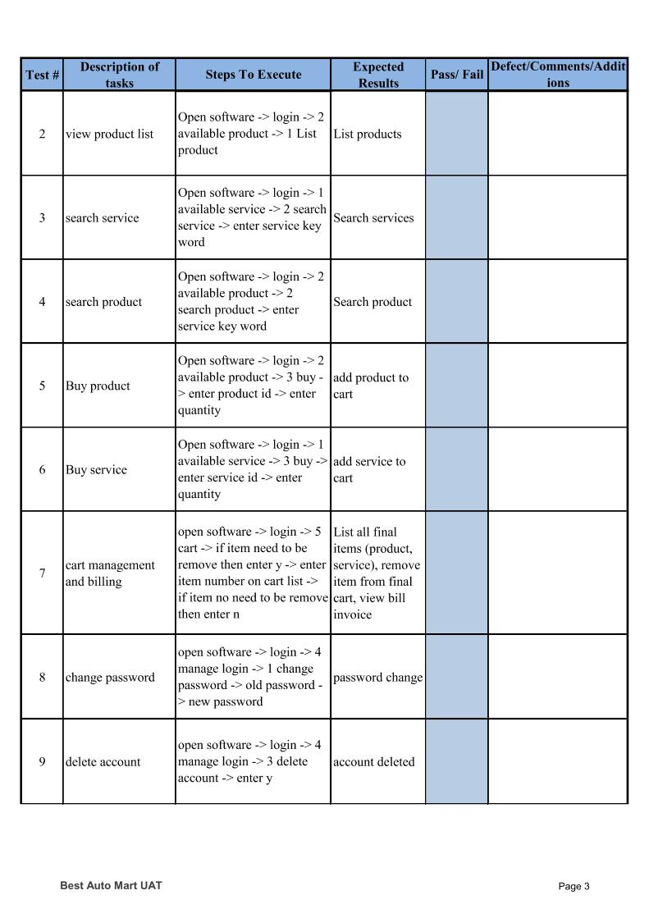

Figure 144 UAT sample questionnaire page 3

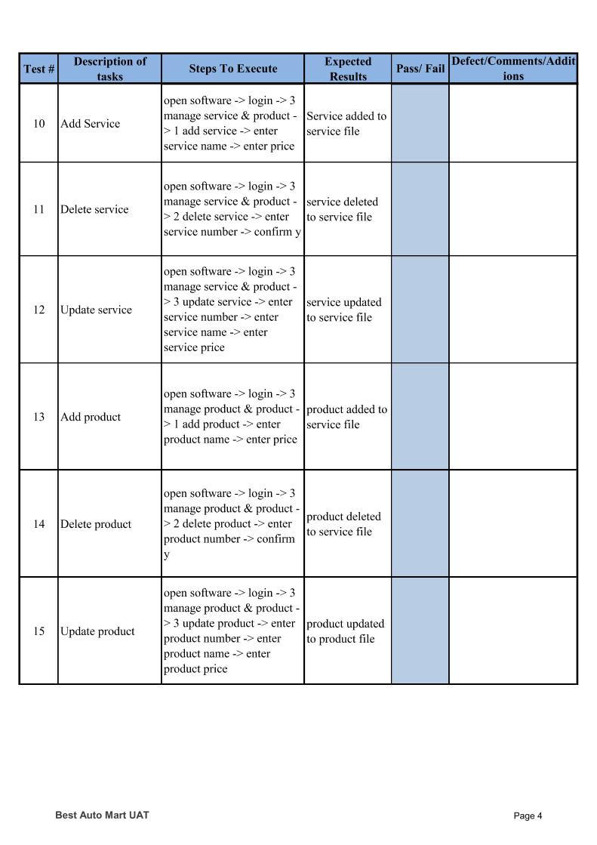

Figure 145 UAT sample questionnaire page 4

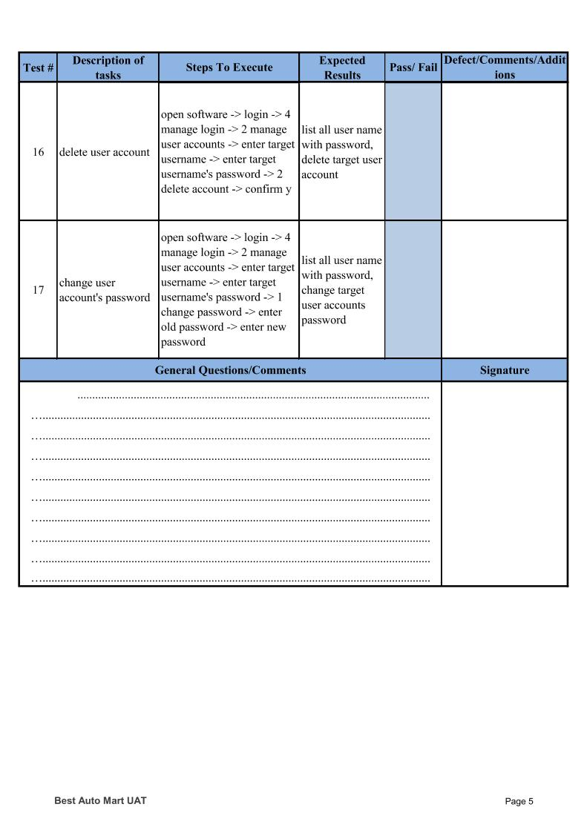

Figure 146 UAT sample questionnaire page 5

### User feedback

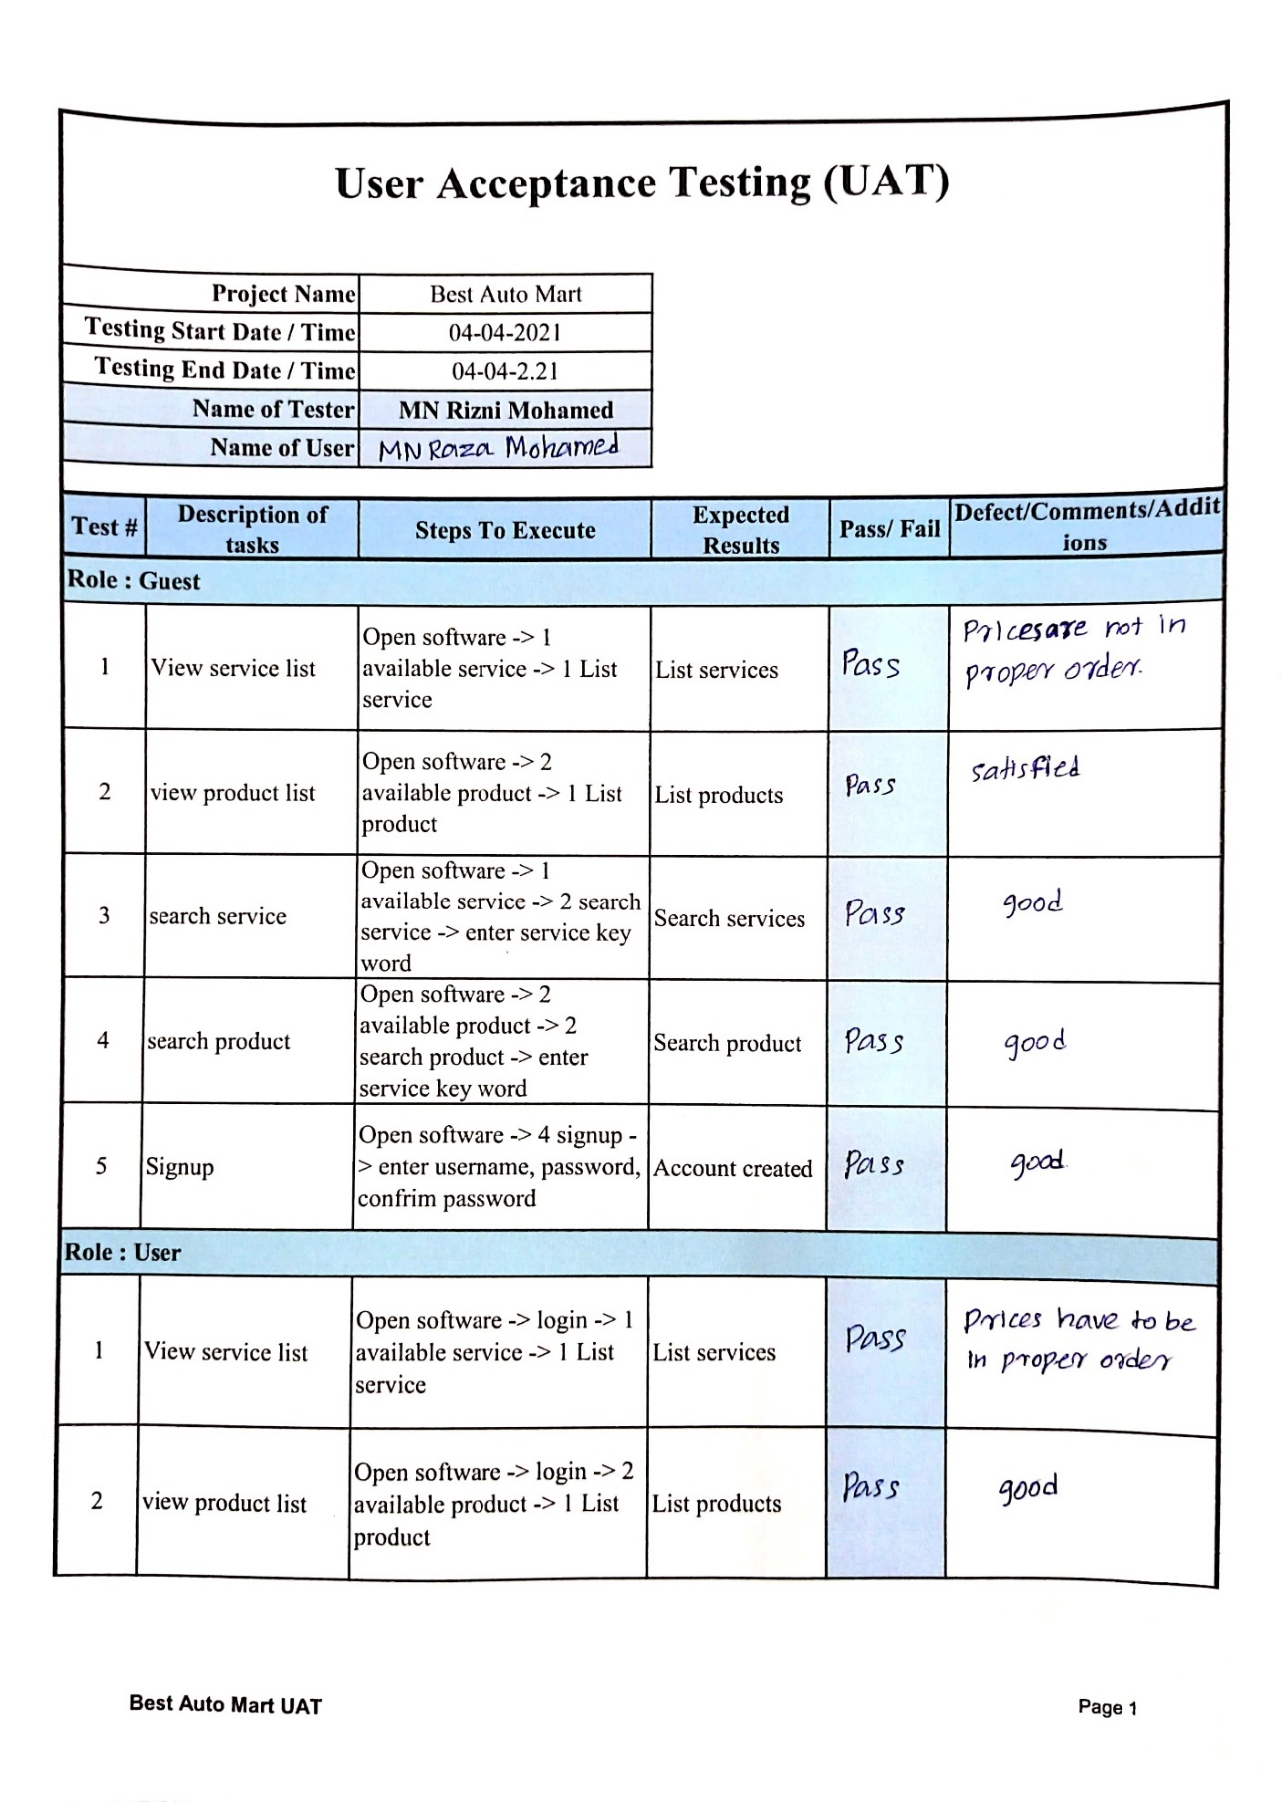

Figure 147 UAT user feedback page 1

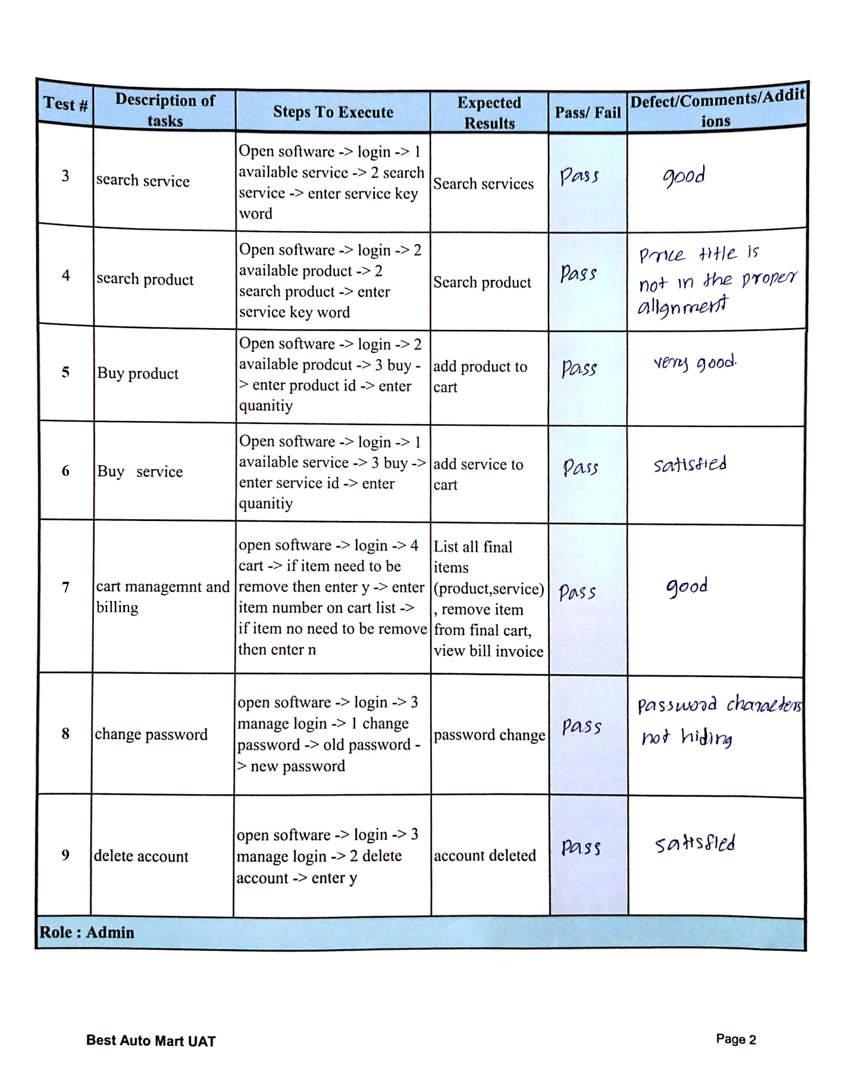

Figure 148 UAT user feedback page 2

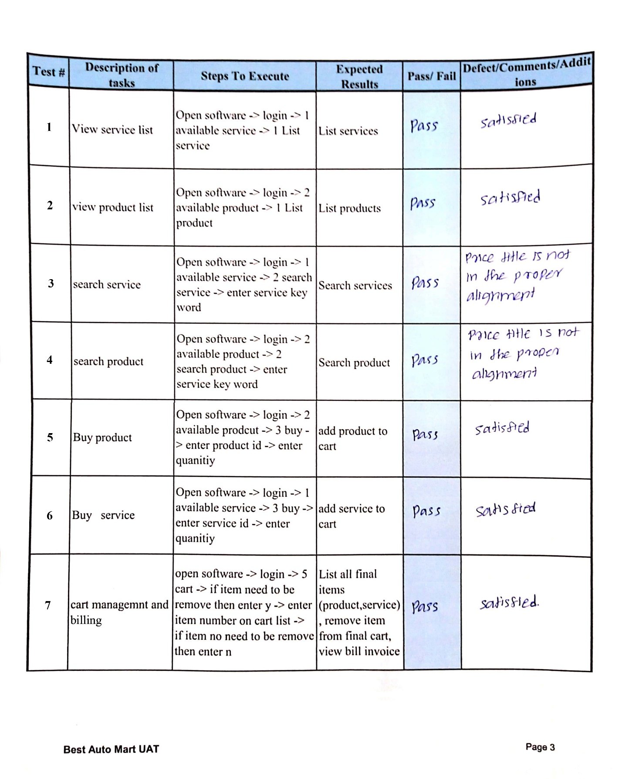

Figure 149 UAT user feedback page 3

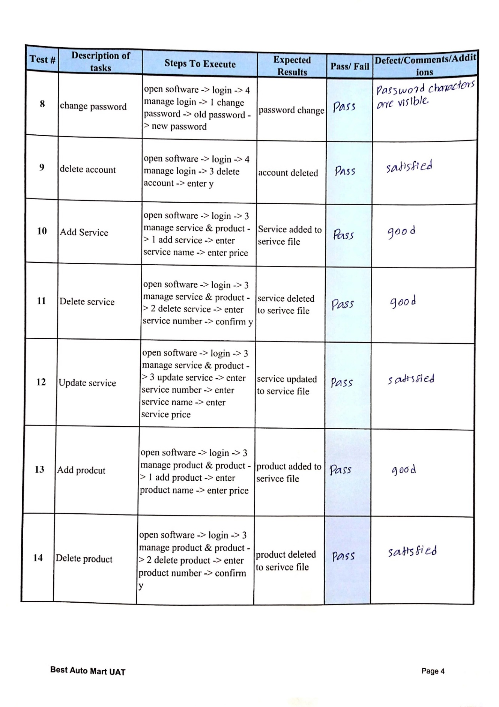

Figure 150 UAT user feedback page 4

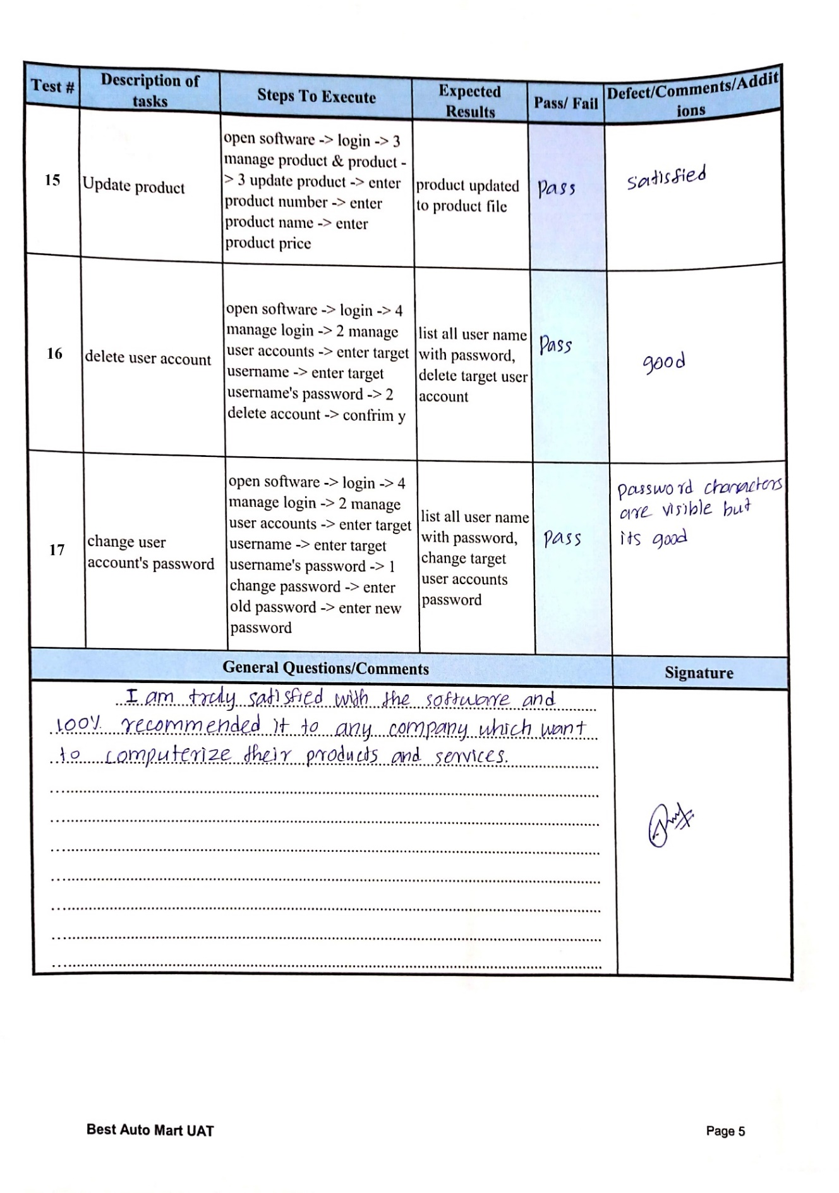

Figure 151 UAT user feedback page 5

### Test conclusion

Test cases and test summery reports are depicting that all the functionalities are meet the requirements successfully according to test exit criteria. Although, the user feedbacks say there two non-functionalities are need to be modified. Those are mentioned below

* In View service list, search product, search service processes, the tile of service/product and price are not in proper alignment
* When typing password, characters are visible

Since above bugs are non-functional requirements, this system can go live to the company for managing their works and these bugs will fixes in next version release

# Future Recommendation

Following are some of the suggestions that could be added as enhancements to the existing system to make the system a much-improved product in future.

* Make proper alignments in View service list, search product, search service processes
* Make password characters are hidden when typing it
* Give GUI interface to this program by QT framework
* Convert all local database into server-based database like MYSQL, SQL, Firebase
* Make live this software on server to give remote access
* Give reset account password way to users like OTP verification

# References

* Aristides S. Bouras. 2021. What is the Sequence Control Structure?. [online] Available at: <https://www.bouraspage.com/repository/algorithmic-thinking/what-is-the-sequence-control-structure> [Accessed 24 April 2021].
* Cs.fsu.edu. 2021. Control Structures. [online] Available at: <https://www.cs.fsu.edu/~myers/c++/notes/control1.html> [Accessed 23 April 2021].
* Developer Insider. 2021. The Decision Control Structure - C Programming. [online] Available at: <https://developerinsider.co/the-decision-control-structure-c-programming/> [Accessed 23 April 2021].
* Educative: Interactive Courses for Software Developers. 2021. What is Object Oriented Programming? OOP Explained in Depth. [online] Available at: <https://www.educative.io/blog/object-oriented-programming?aid=5082902844932096> [Accessed 23 April 2021].
* En.wikipedia.org. 2021. Logic programming - Wikipedia. [online] Available at: <https://en.wikipedia.org/wiki/Logic_programming> [Accessed 23 April 2021].
* GeeksforGeeks. 2021. Differences between Procedural and Object Oriented Programming - GeeksforGeeks. [online] Available at: <https://www.geeksforgeeks.org/differences-between-procedural-and-object-oriented-programming> [Accessed 23 April 2021].
* Medium. 2021. Master the JavaScript Interview: What is Functional Programming?. [online] Available at: <https://medium.com/javascript-scene/master-the-javascript-interview-what-is-functional-programming-7f218c68b3a0> [Accessed 23 April 2021].
* Tutorialspoint.com. 2021. Applying Modular Techniques - Tutorialspoint. [online] Available at: <https://www.tutorialspoint.com/programming_methodologies/programming_methodologies_applying_modular_techniques.htm> [Accessed 23 April 2021].
* Tutorialspoint.com. 2021. Programming Methodologies - Introduction - Tutorialspoint. [online] Available at: <https://www.tutorialspoint.com/programming_methodologies/programming_methodologies_introduction.htm> [Accessed 23 April 2021].
* 2021. [online] Available at: <https://www.softwaretestinghelp.com/test-summary-report-template-download-sample.> [Accessed 27 April 2021].
* En.wikipedia.org. 2021. For loop - Wikipedia. [online] Available at: <https://en.wikipedia.org/wiki/For_loop> [Accessed 24 April 2021].
* Homepages.uc.edu. 2021. Intro to Repetition Structures. [online] Available at: <https://homepages.uc.edu/~thomam/Intro_OOP_Text/Loops.html> [Accessed 24 April 2021].
* Jain, M., Jain, M., Testing, Q. and Soma, S., 2021. Software Requirement Specification (SRS). [online] Software Testing Class. Available at: <https://www.softwaretestingclass.com/software-requirement-specification-srs/> [Accessed 24 April 2021].
* W3schools.com. 2021. JavaScript while Loop. [online] Available at: <https://www.w3schools.com/js/js_loop_while.asp> [Accessed 24 April 2021].
* En.wikipedia.org. 2021. Test case - Wikipedia. [online] Available at: <https://en.wikipedia.org/wiki/Test_case> [Accessed 26 April 2021].
* Asq.org. 2021. What is a Flowchart? Process Flow Diagrams & Maps | ASQ. [online] Available at: <https://asq.org/quality-resources/flowchart> [Accessed 28 April 2021].
* En.wikipedia.org. 2021. Modular programming - Wikipedia. [online] Available at: <https://en.wikipedia.org/wiki/Modular_programming> [Accessed 29 April 2021].
* Sciencedirect.com. 2021. Process Flow Diagram - an overview | ScienceDirect Topics.[online]Availableat:<https://www.sciencedirect.com/topics/engineering/process-flow-diagram> [Accessed 28 April 2021].
* SheCanCode. 2021. Software ‘Developer’ or ‘Engineer’: What’s the Difference? — SheCanCode. [online] Available at: <https://shecancode.io/blog/software-developer-or-engineer-whats-the-difference> [Accessed 30 April 2021].

# Appendix

## Questionnaire

